GERMAN WWII PHOTOS
GERETE PHOTOS
I will on this page show photos of various technical equipment.
This is pictures from my German Photo Collection.
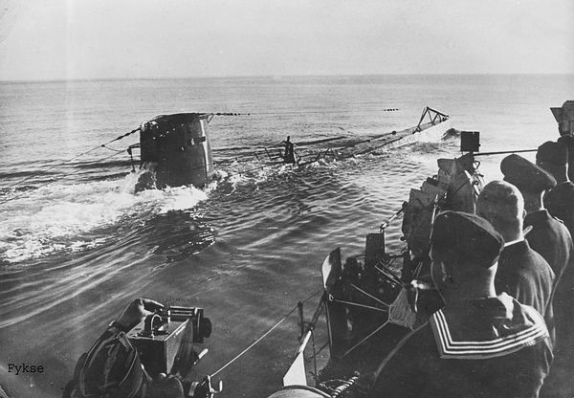
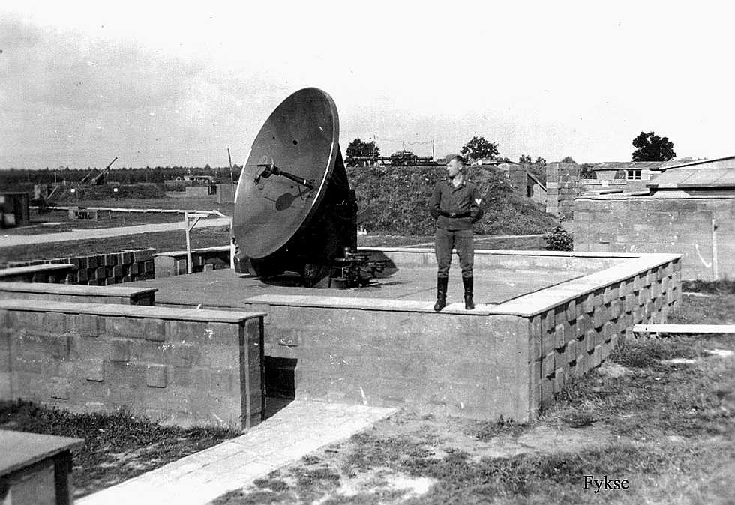
Wurzburg , FuMG 62
Short-range ground fire control radar. Range 170km, frequency 560MHz, range precision 100m, angle precision 0.2 degrees.
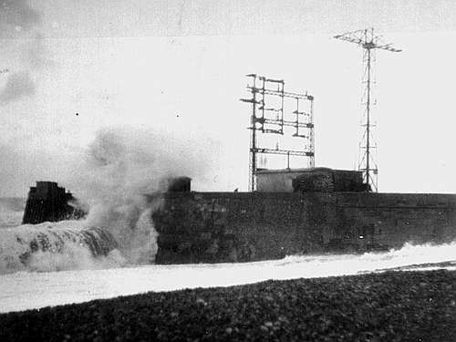
Radar
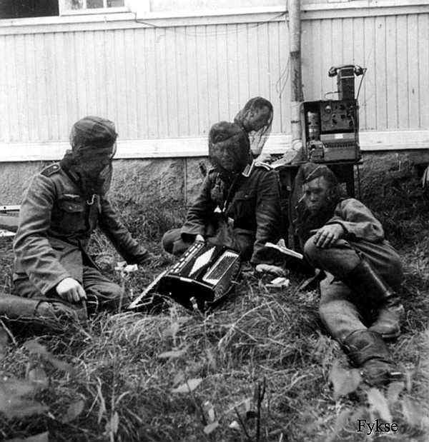
Field Hell. The photo is from Lapland
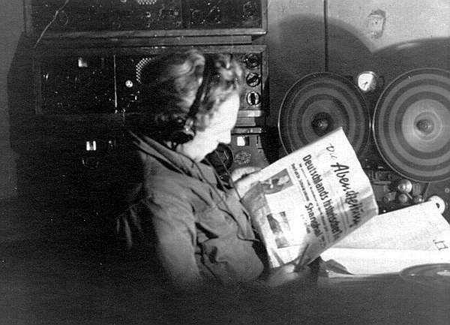
Tape-recorder in use.
A broadcast transmitter is connected to the tape-recorded.
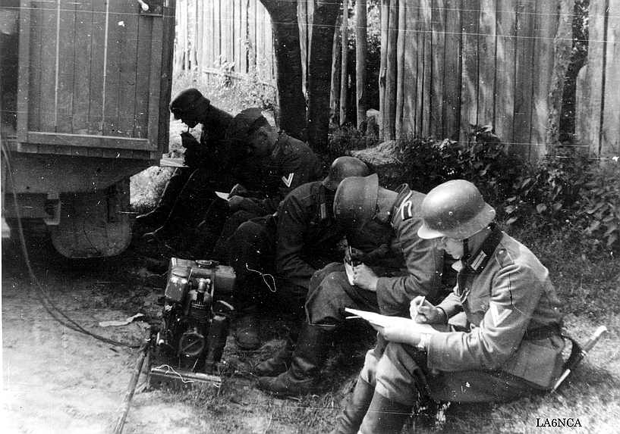
Power generator delivers power to a communication vehicle.
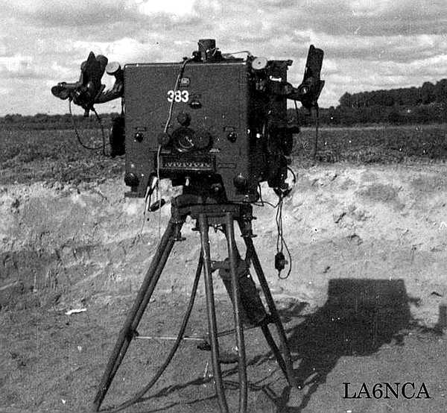
The device above is the Kdo.Hi.Ger. 35 or Kommando Hilfsgeraet 35, an antiaircraft artillery command
device used as the secondary unit of a heavy antiaircraft battery (cal. 8,8 cm upwards), the primary unit
being either the Kdo.Ger. 36 or the Kdo.Ger. 40, both of them, as opposed to this one, were more complex,
coupled with a 4 m-class rangefinder and offered electric wire transmission of calculated elevation, traverse
and fuse setting to the guns. Range was given to the Kdo.Hi.Ger. 35 verbally from a free standing 4 m rangefinder,
while target's traverse and elevation were observed with two optical sights visible on both sides of the device.
Calculated values were given to the guns verbally via a phone line. The Kdo.Hi.Ger. 35 together with an
accompanying rangefinder were manned by 14 men, 9 of them operating the command device alone.
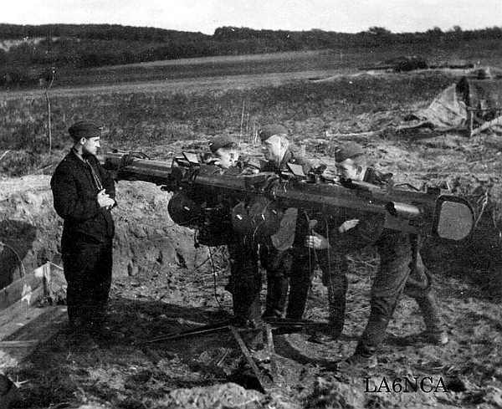
This is a 4 m antiaircraft rangefinder, the EM 4 m R (H) 34 or 36, the Entfernungsmesser 4 m
Raumbild (Hochenmesser) 34 or 36, a standard 4 m-class rangefinder of heavy antiaircraft batteries.
It (as well as a newer, slightly different Em 4m R 40) could be used as a free standing on a tripod base,
as seen here - in co-operation with the Kdo.Hi.Ger. 35, or coupled directly with the Kdo.Ger. 36 or Kdo.Ger. 40.
The Em 4 m R (H) 34 or 36 were manned by 4 men (3 aimers and a commander) and could measure ranges
from 620 m (670 m in case of the model 34) to 50 000 m, as well as target's altitude
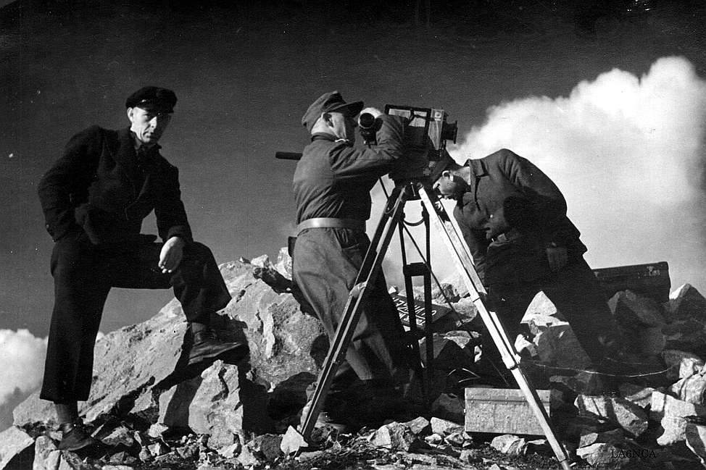
A German war film photograph in action.

GERMAN WWII Torn.Fu.b1 PHOTOS - 1
Torn.Fu.b1 – Torn.Fu.c – Torn.Fu.f
This is a portable field transceiver used by the German army.
Frequency range in MHz:
Type | Transmitter | Receiver
Torn.Fu.b1 | 3.0 – 5.0 | 3.0 – 6.66
Torn.Fu.c | 1.5 – 2.3 | 1.5 – 2.6
Torn.Fu.f | 4.5 – 6.66 | 3.0 – 6.66
This transceiver was developed by Lorenz in 1935/36.
Output power is 1 Watt. Modulation is A1 and A3.
Total weight with accessory box is 20 kg.
Tube used is RV2P800 and one RL2P3 in the transmitter.
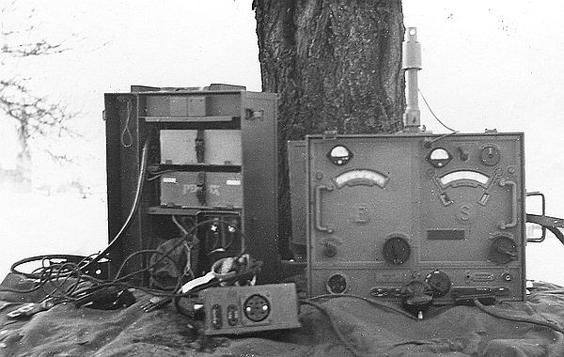

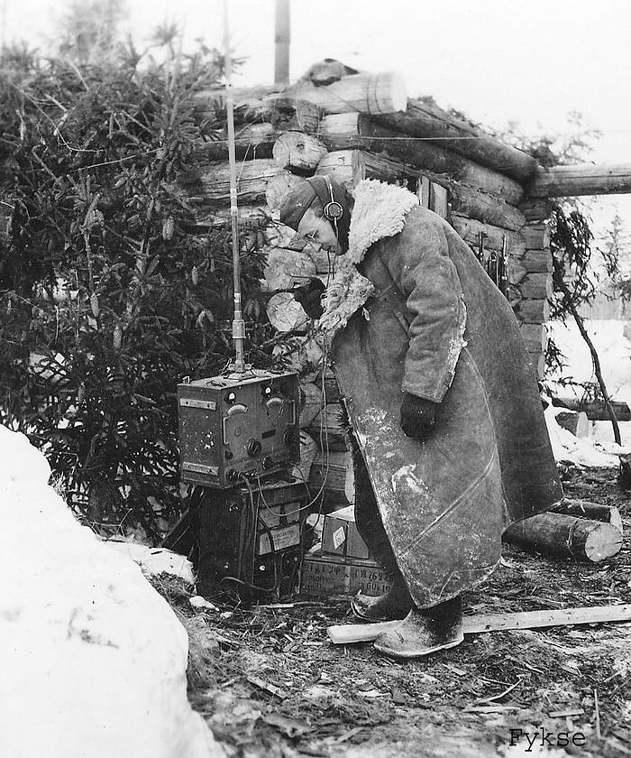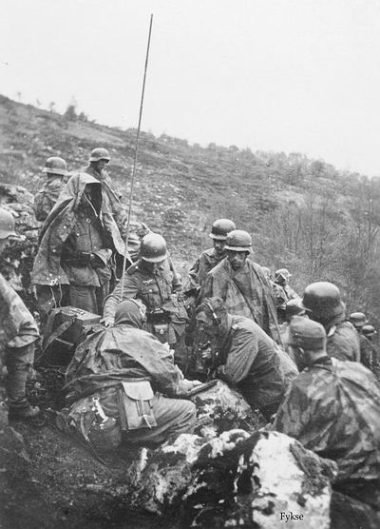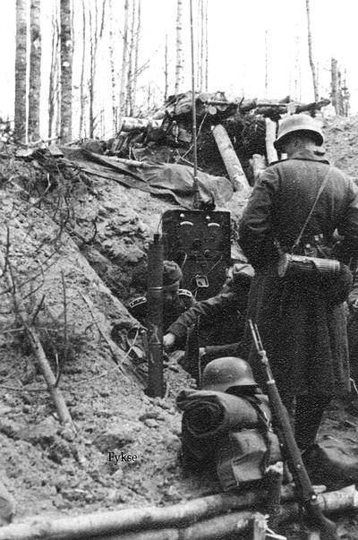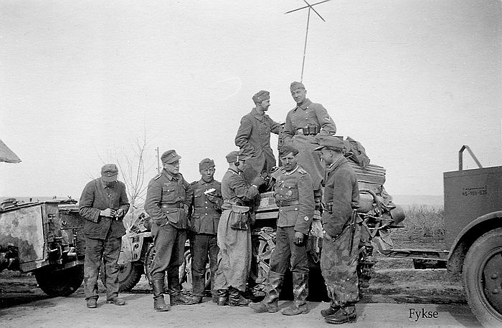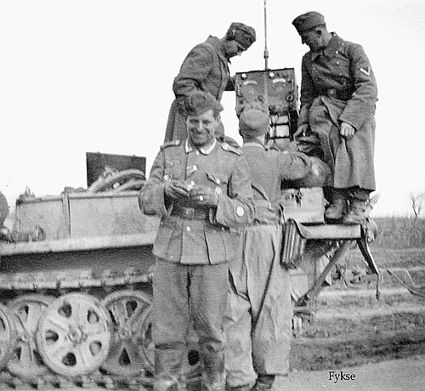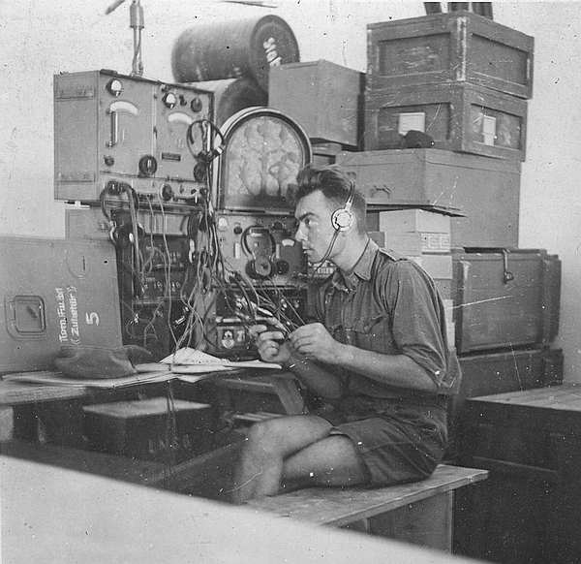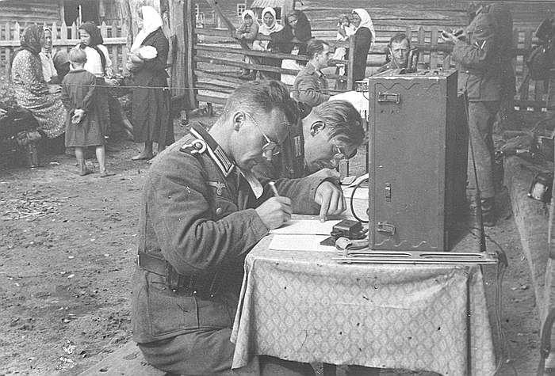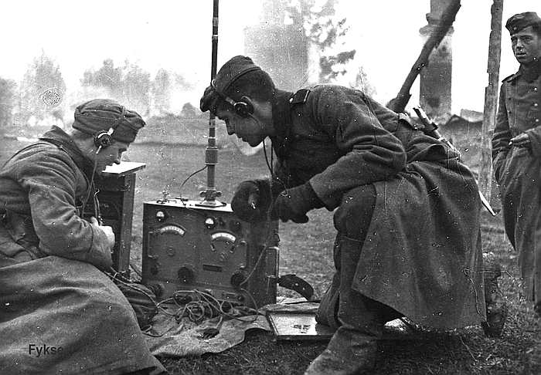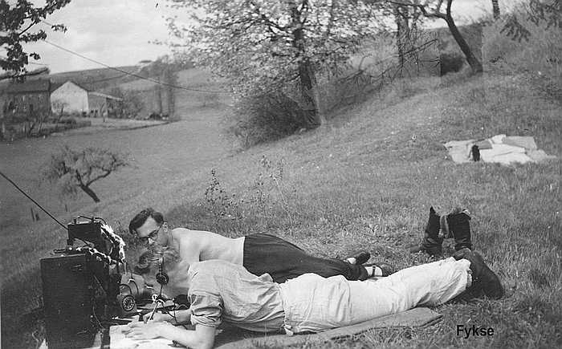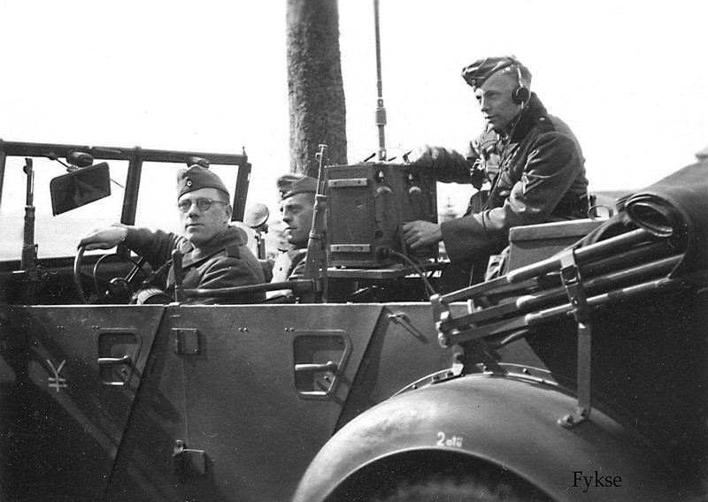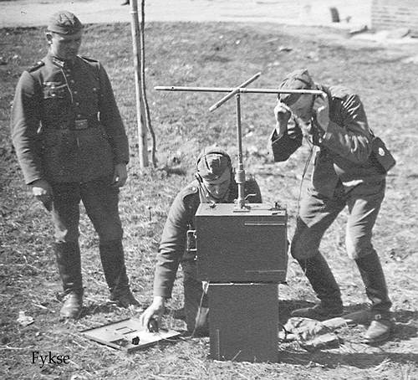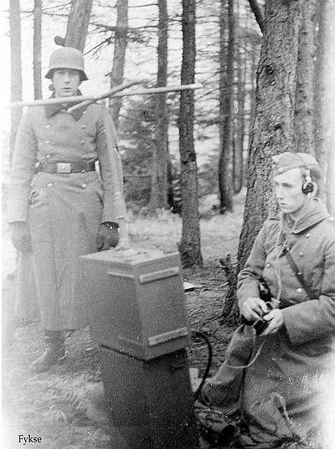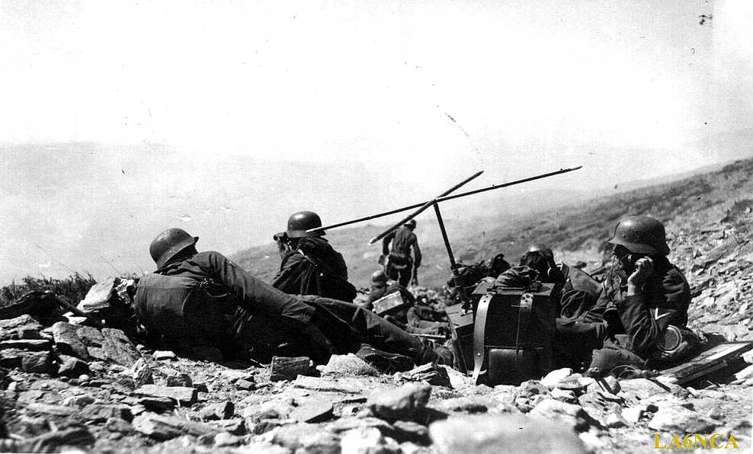
"Angriff !"
"B-stelle mit Funkgerät"
German soldiers from a mountain unit (Gebirgsjägers) have created an OP post with radio.
The German army attacks the enemy down the valley.
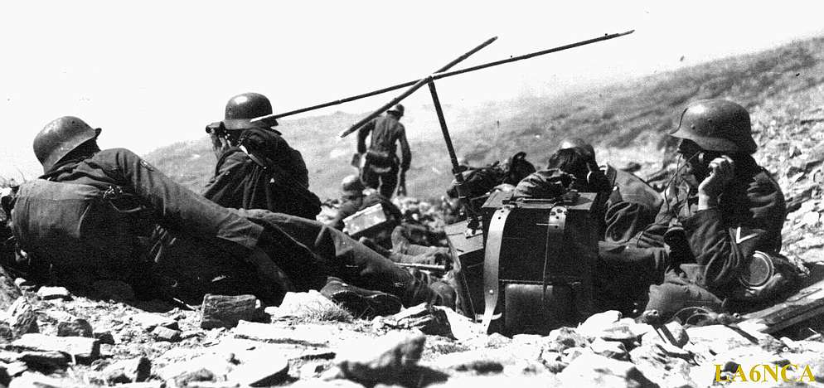
Torn. Fu. b1 with a very short antenna. The radio operators sends observation information down to the army.
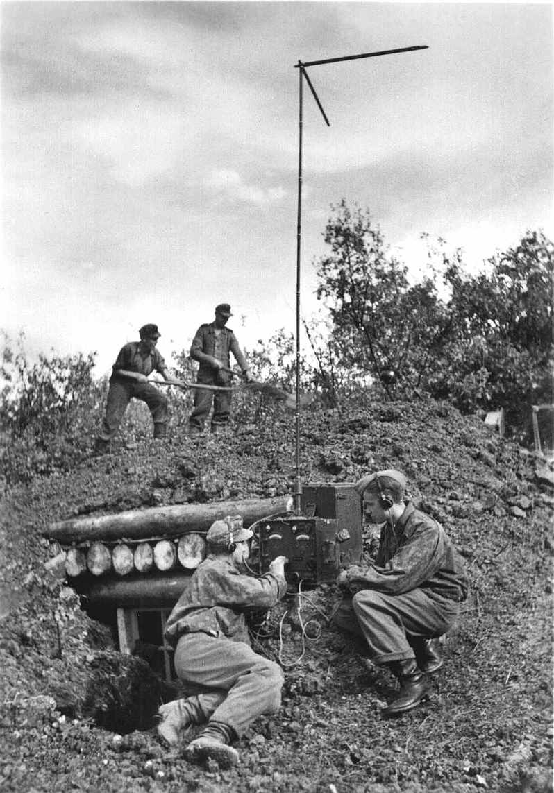
Waffen SS-soldiers tests the radio set while other soldiers is working on the bunker.
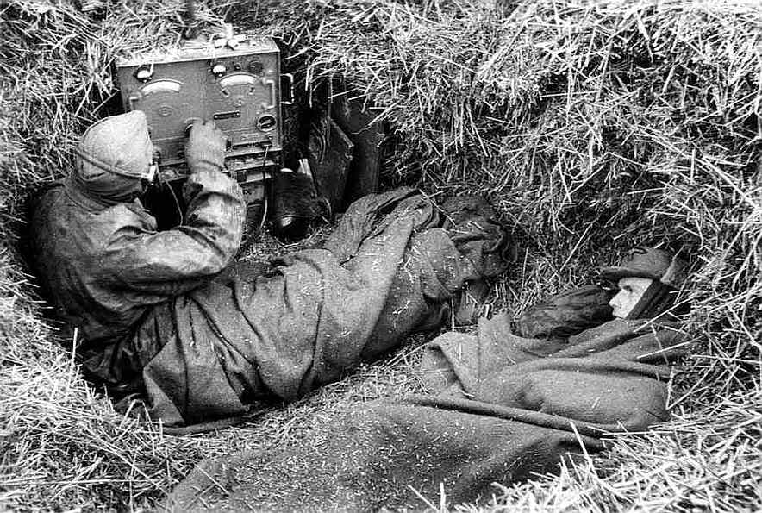
Waffen SS-soldiers on radio duty at the front.
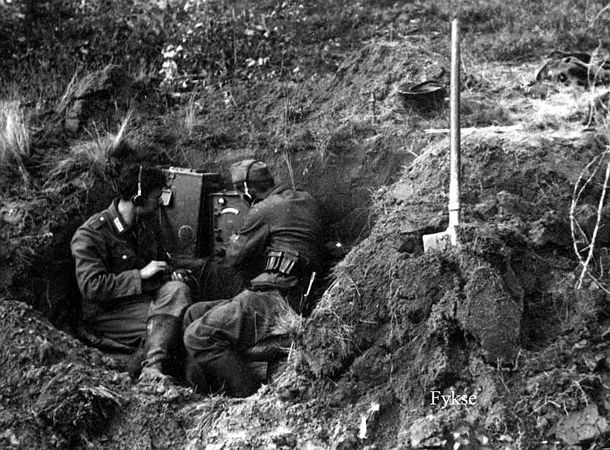
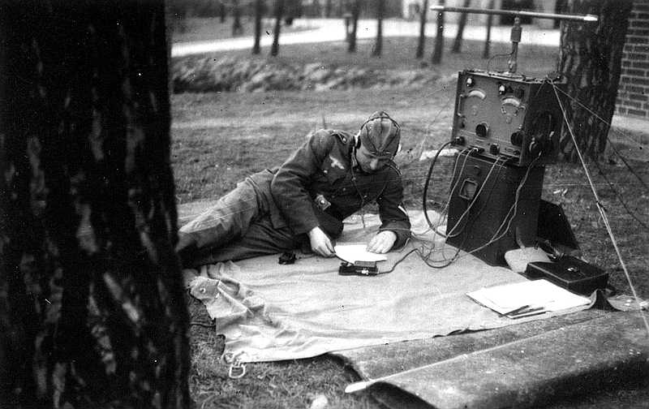
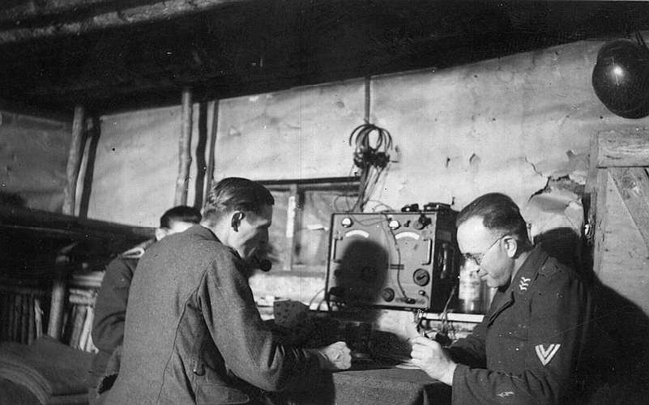
Torn.Fu.b1 in a bunker. The Luftwaffe soldiers takes their time off, playing card.
Note : The soldier on the right has the "Nachrichtenblitz" on his lower left sleeve instead of above his chevron were it normally was worn.
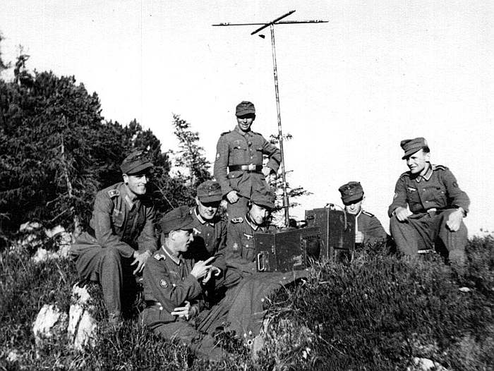
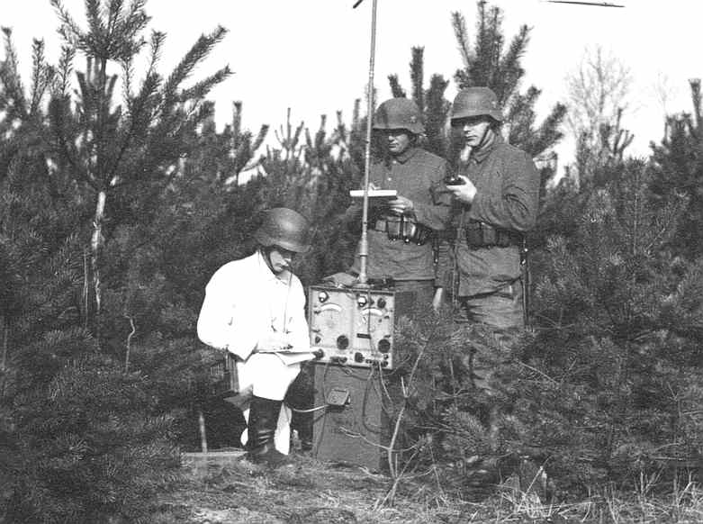
Torn.Fu.b1 in the field. Army personel is wearing the "Drillich-anzug".
This uniform was often used to save the field uniform from dirt and damages.
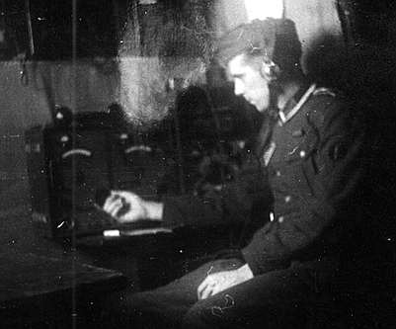

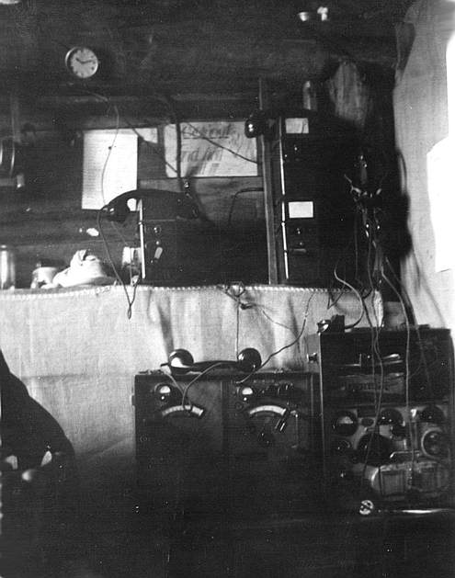
Torn.Fu.b1 and Tornisterempfänger Spez. 445 Bs.
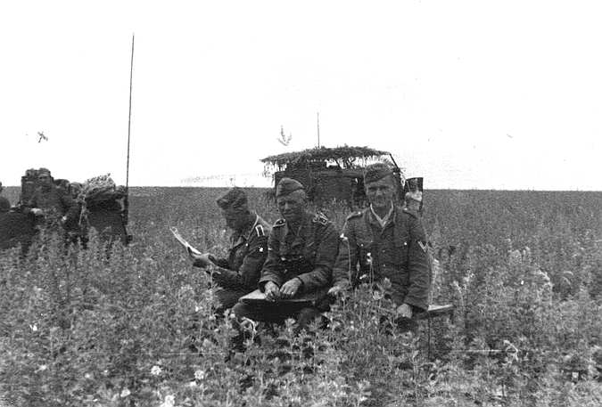
Torn.Fu.B1 mounted in a vehicle with a vertical antenna.
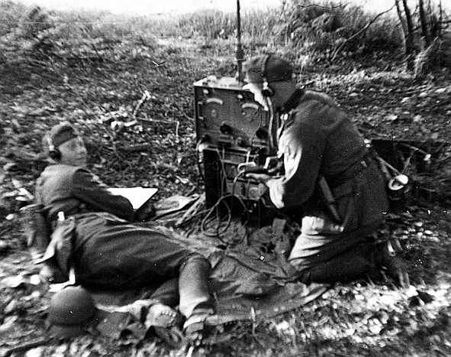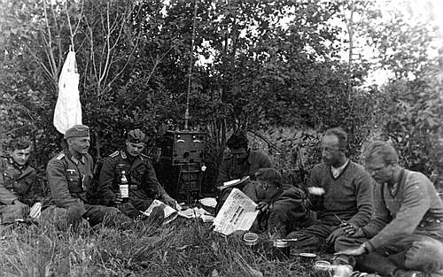
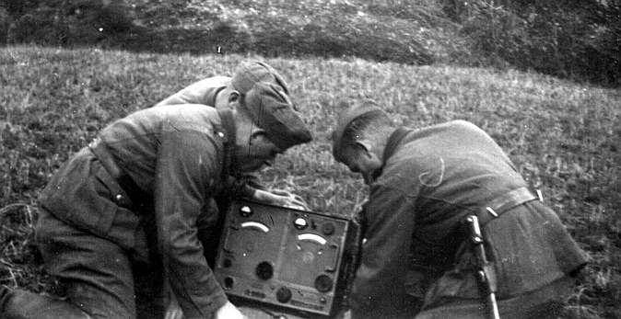
Soldiers working with a Torn.Fu.B1.
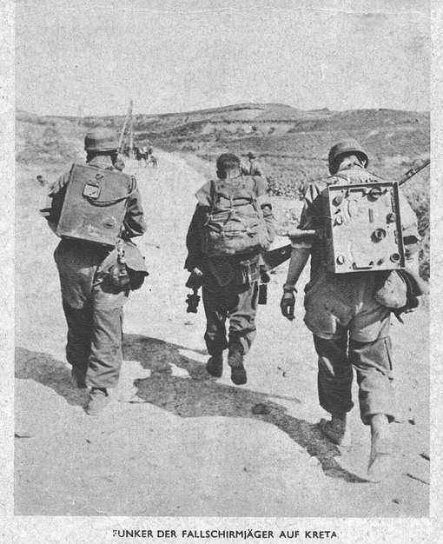
Torn. Fu. b1 in use by German paratroopers during the invasion of Crete 20th. May 1941.
Post-card from Flemming N. B. Melin Christiansen, Norway.

WR1/T broadcast receiver.

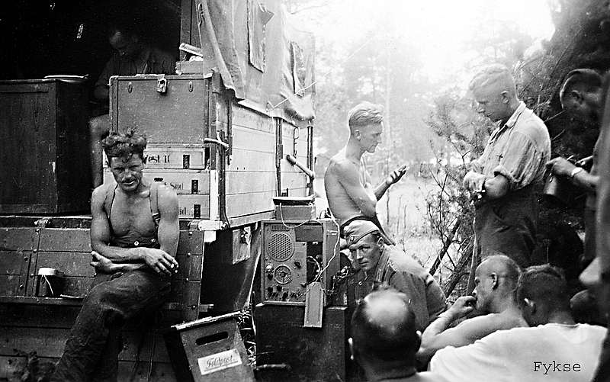
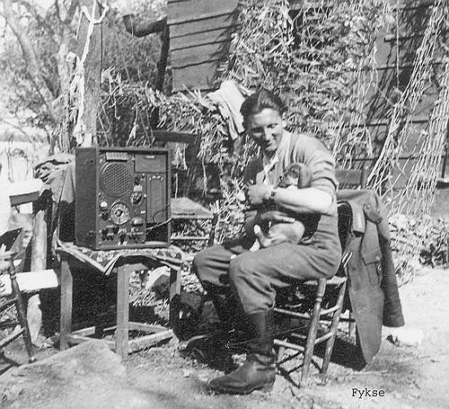
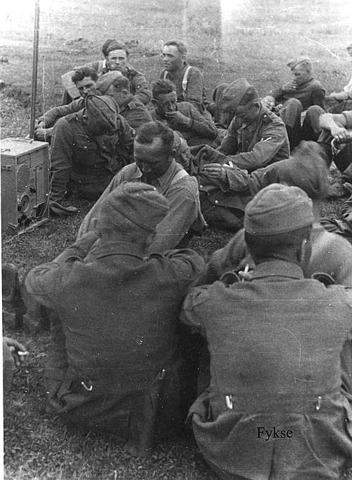
WR1/T broadcast receiver. This is a “troop entertainment receiver” wish was used in the field.
The radio can be operated from both battery and net.
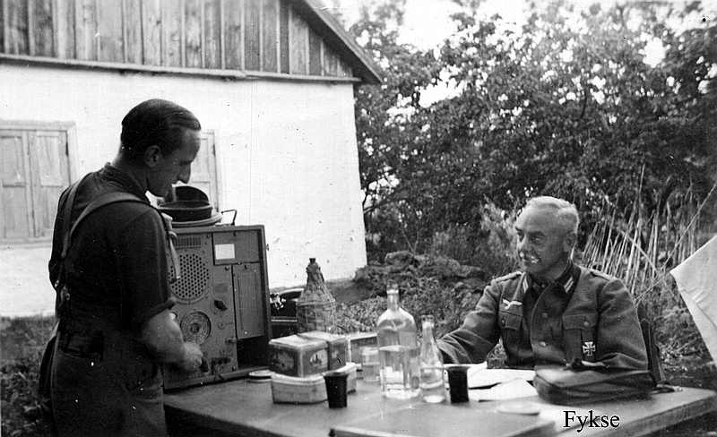
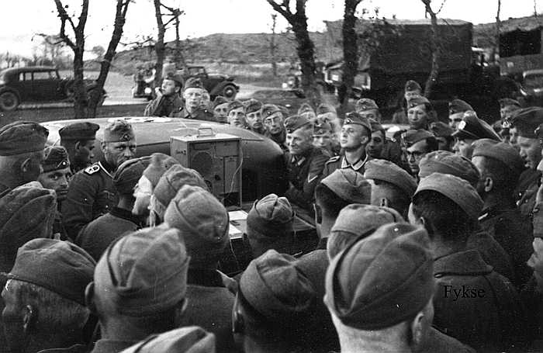
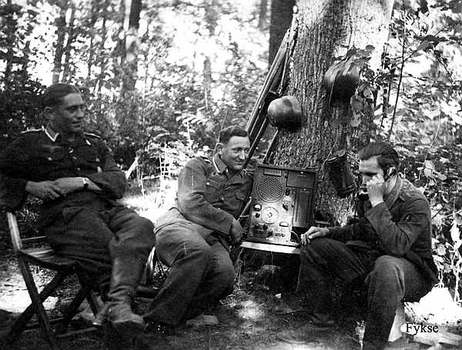
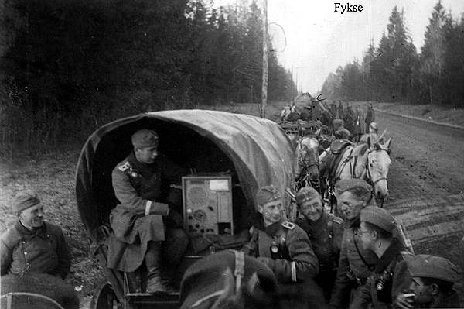
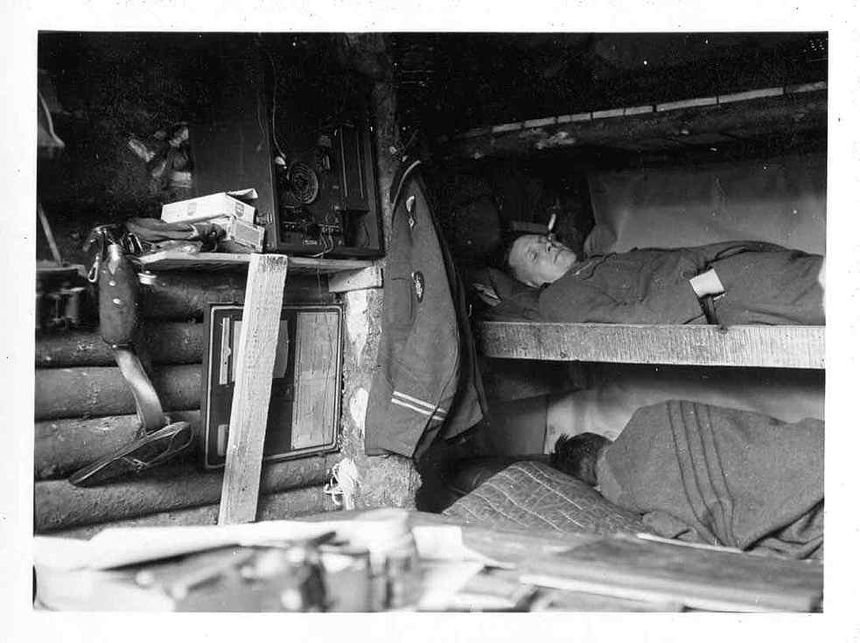

ENIGMA.
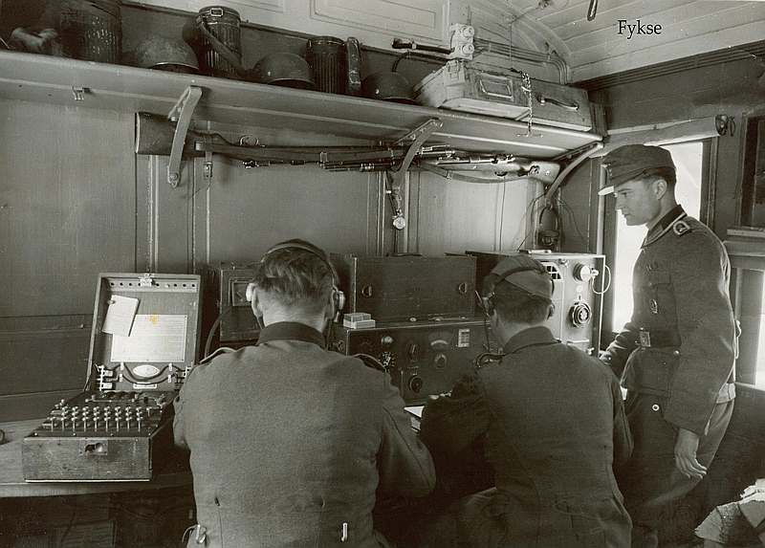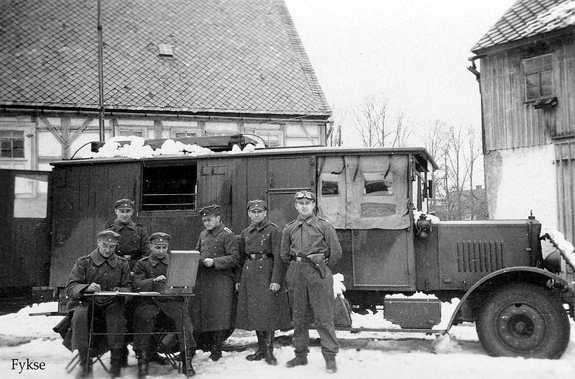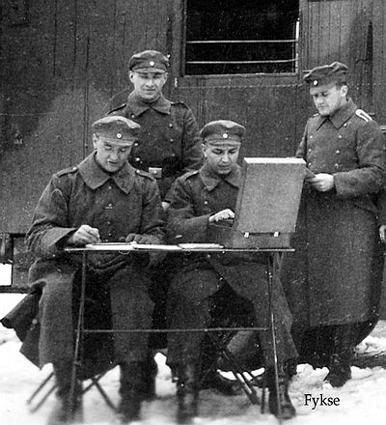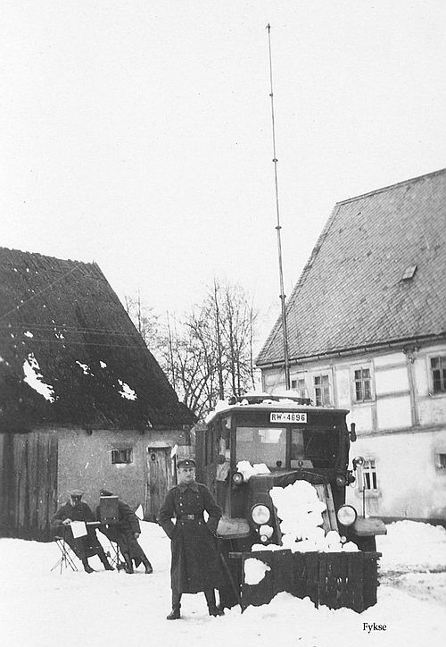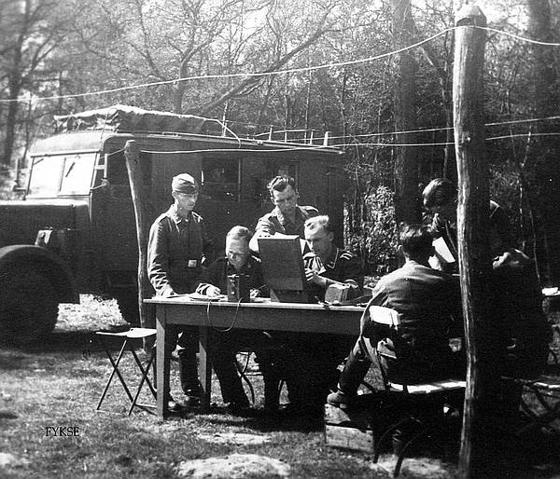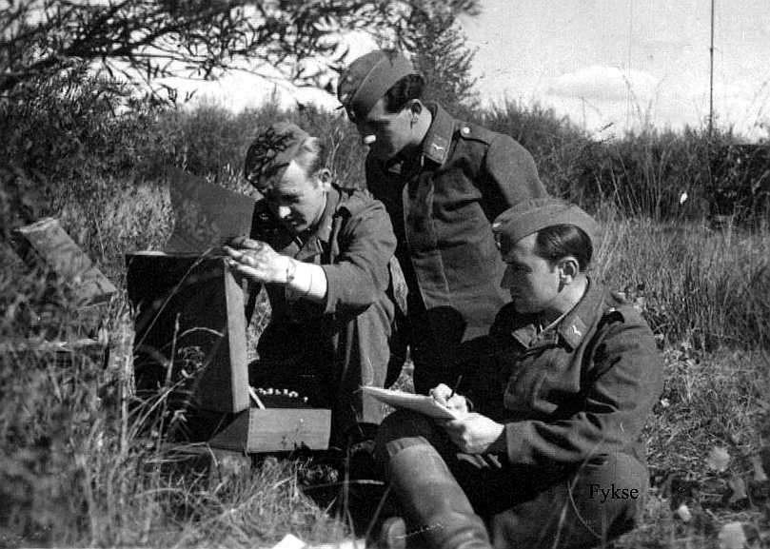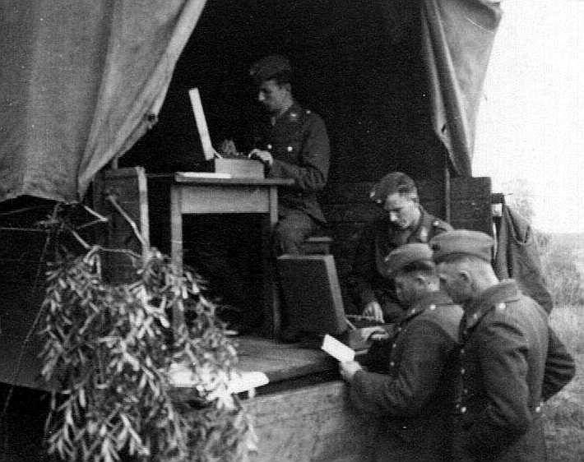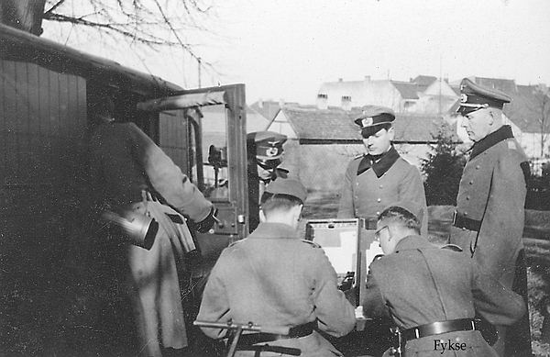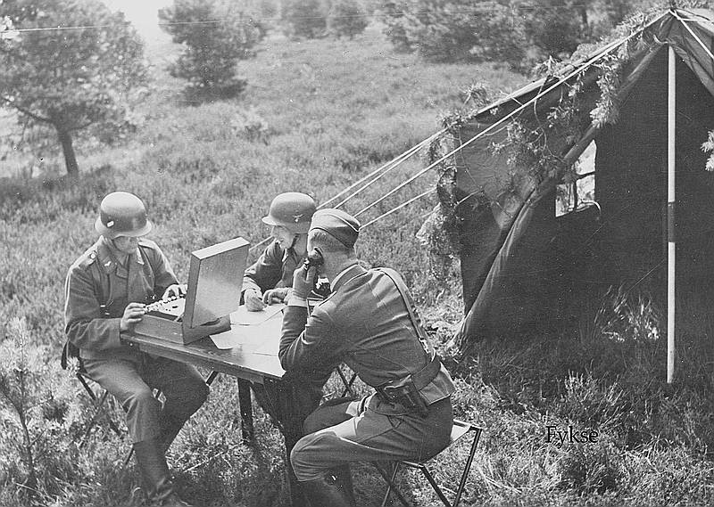

Radio direction finding
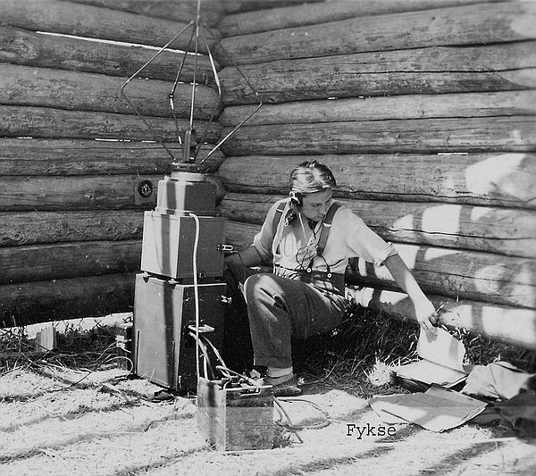
Fu.NP.E a/c
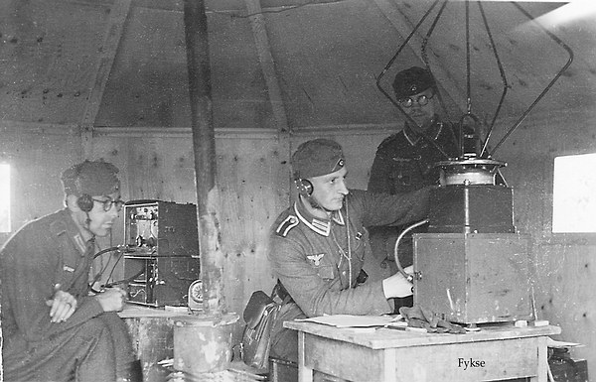
Fu.NP.E a/c
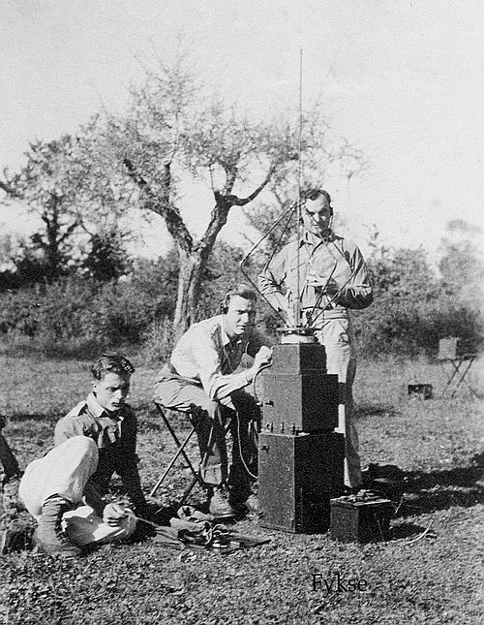
Fu.NP.E a/c

Radio direction finder station in Luftwaffe.
The position to own and enemy airplane is reported.
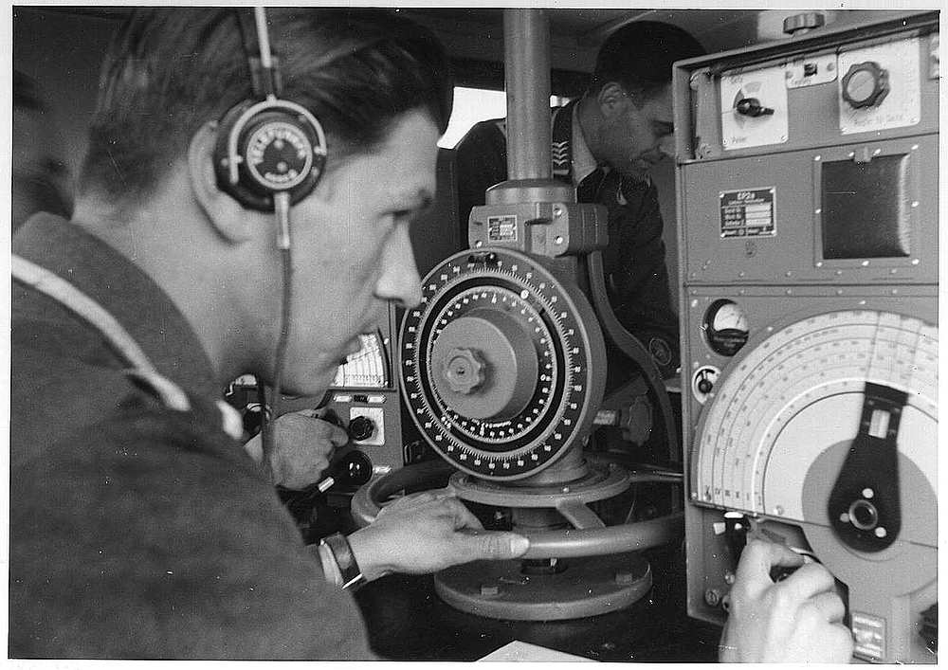
EP2a receiver. 75 kHz – 3333 kHz. (E383 N2/37).
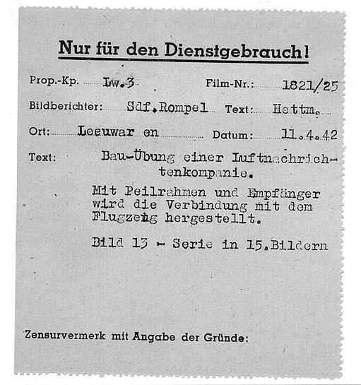

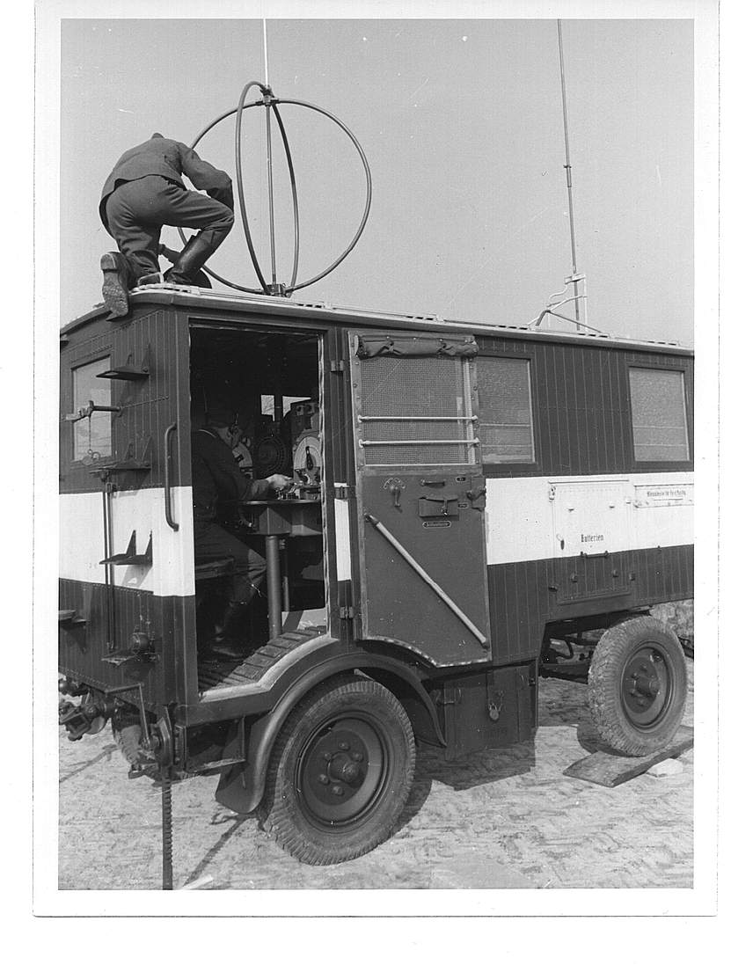
Left: Direction finder antenna for the EP2a receiver, Right: Antenna for the 100WS transmitter.
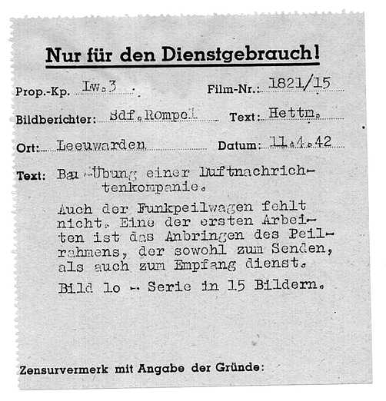

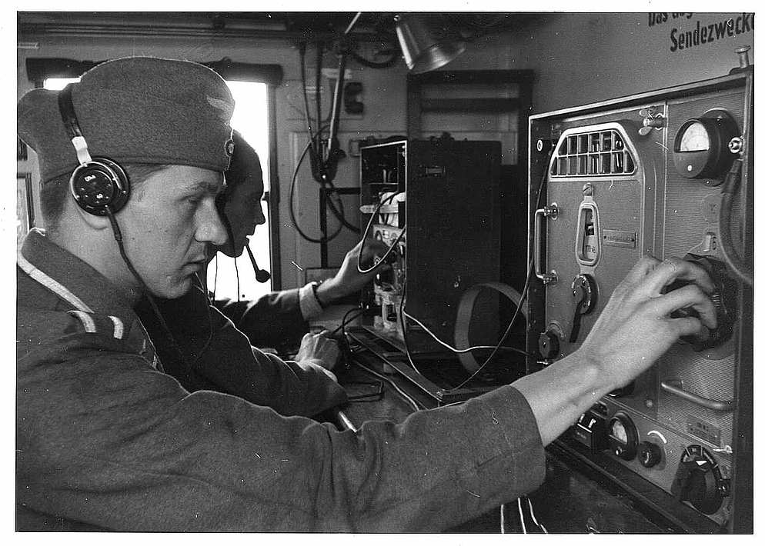
Tornisterempfänger Spez. 445 Bs. receiver and 100WS transmitter.
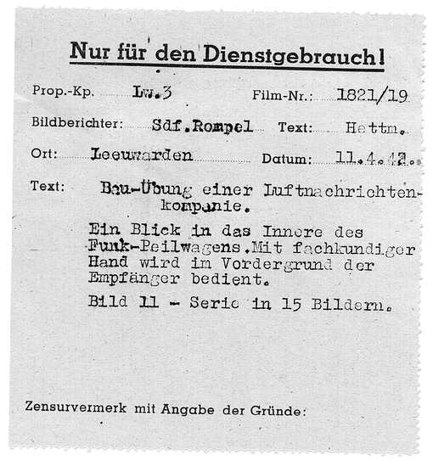

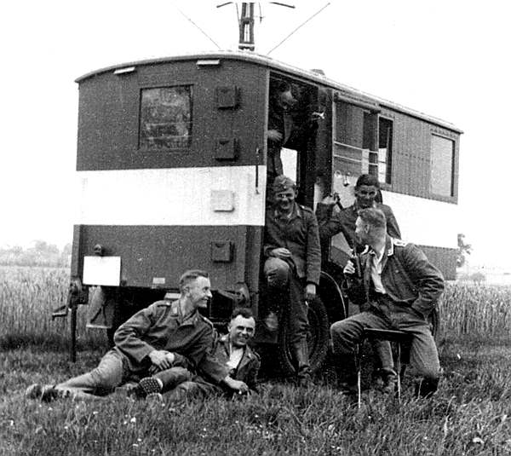
Break in the direction finder work.

Radio direction finder station in the Heer.
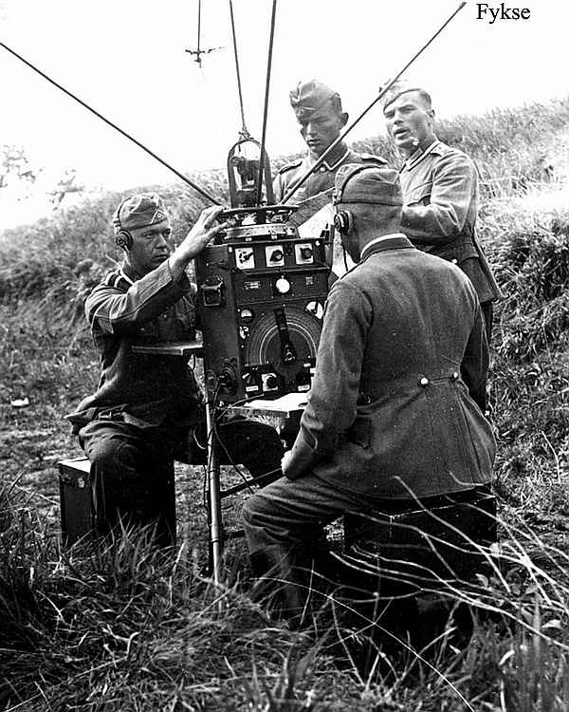
Here is the position to the enemy reported. EP2a receiver with antenna.
Here in Norway such radio systems were used to find illegal radio transmitters.
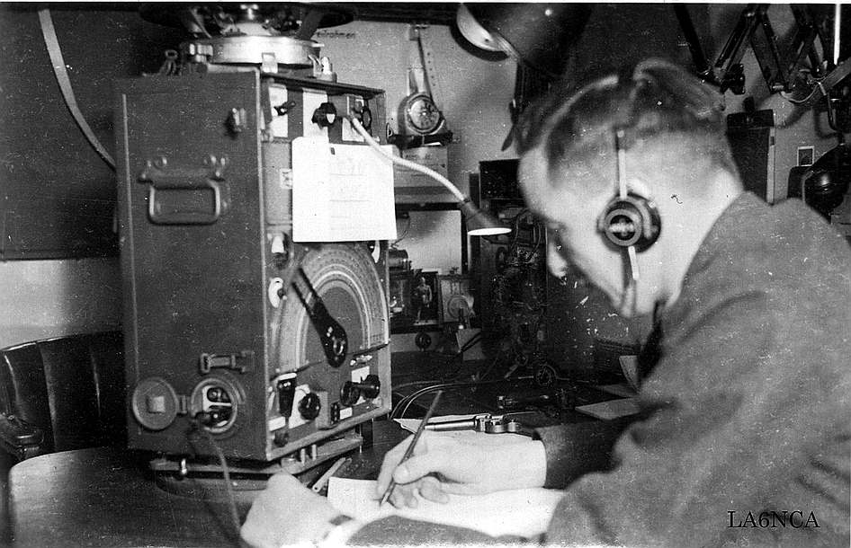
EP2a direction finder receiver with antenna.
In the same vehicle there is a radio station for reporting the direction finder data.
The operator has a pistol at the table.
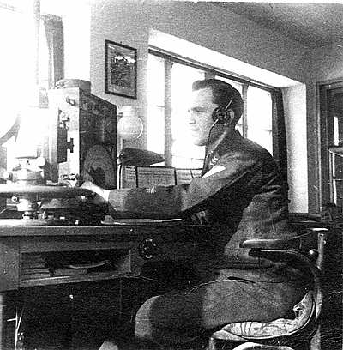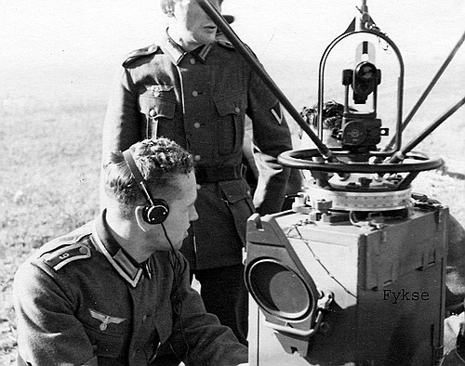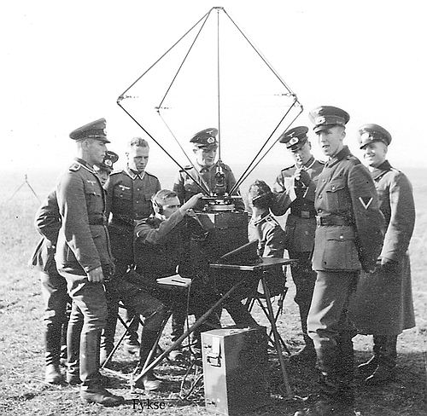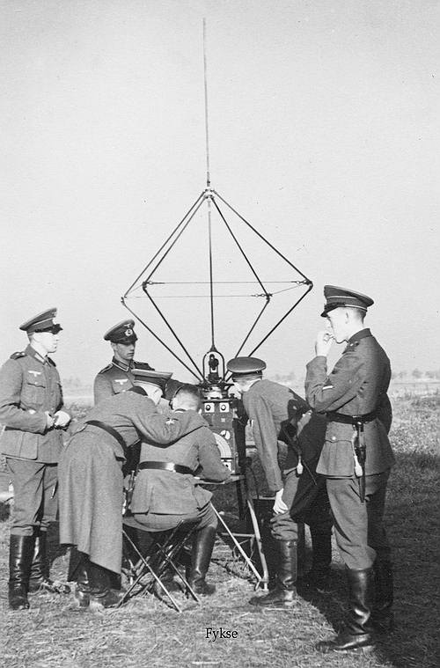

Michael
MICHAEL is an UHF radio link system for telephone and telex communication.
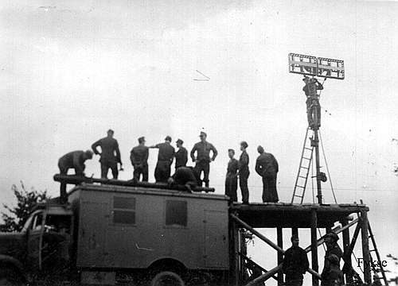
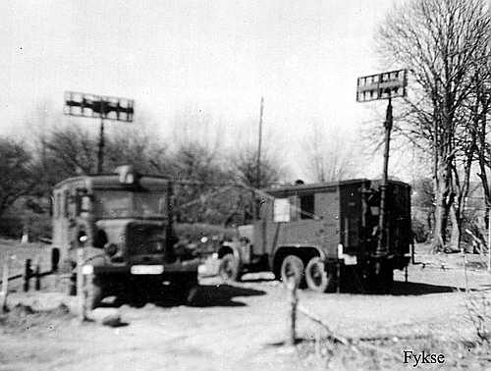
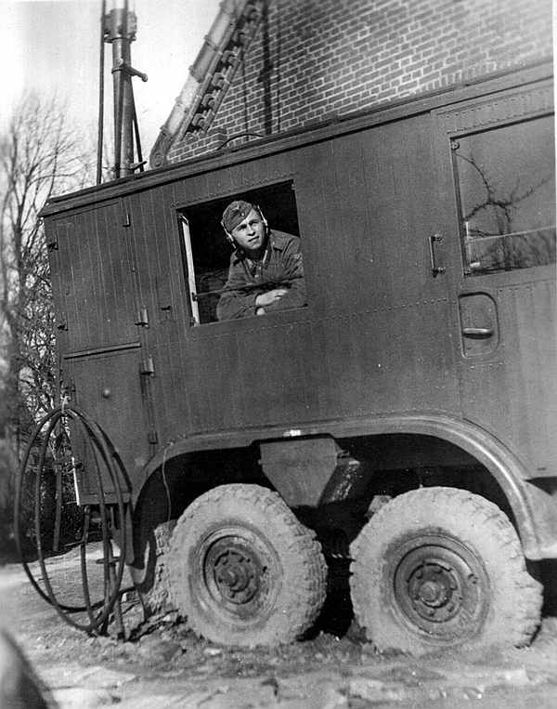
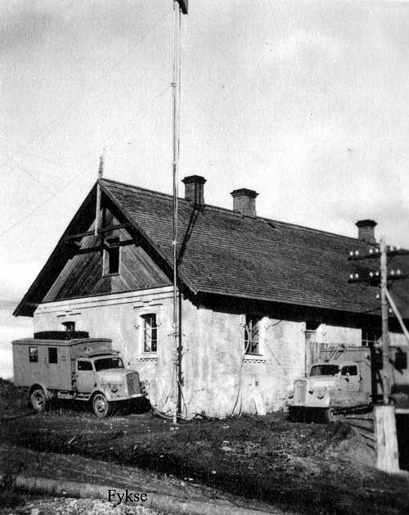
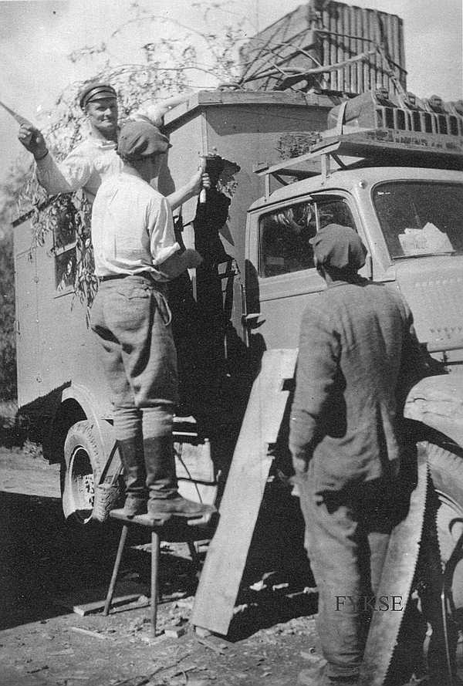
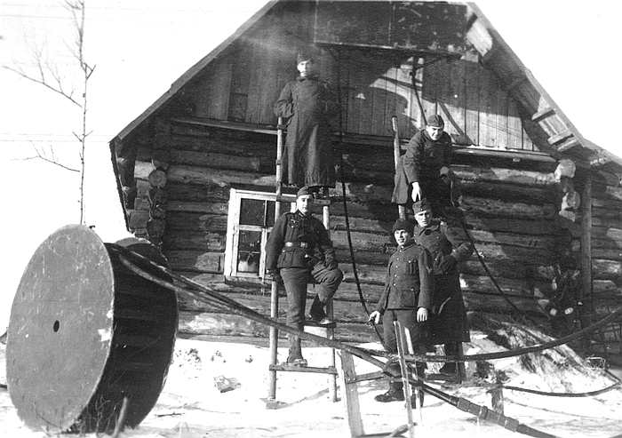
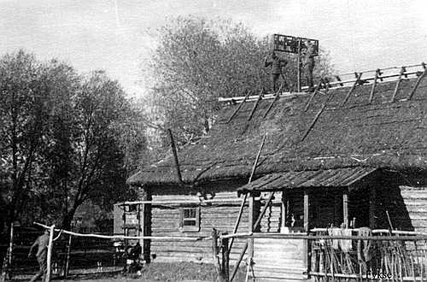
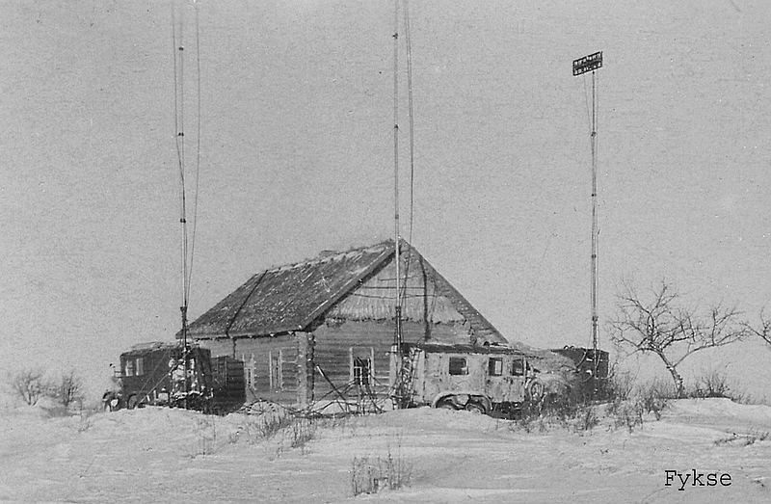
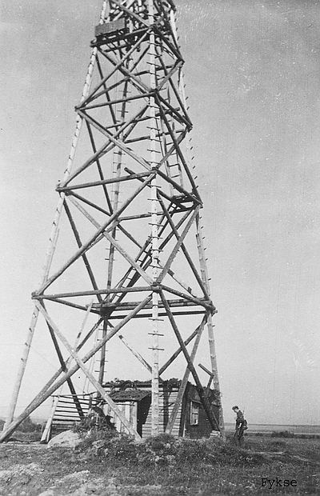
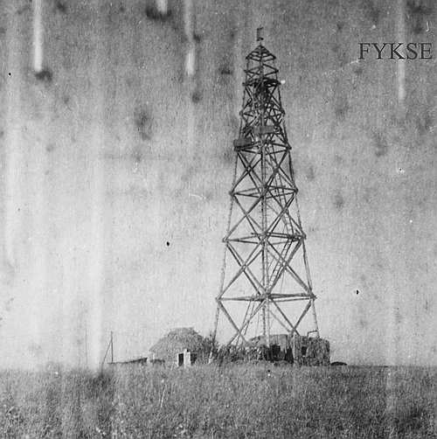
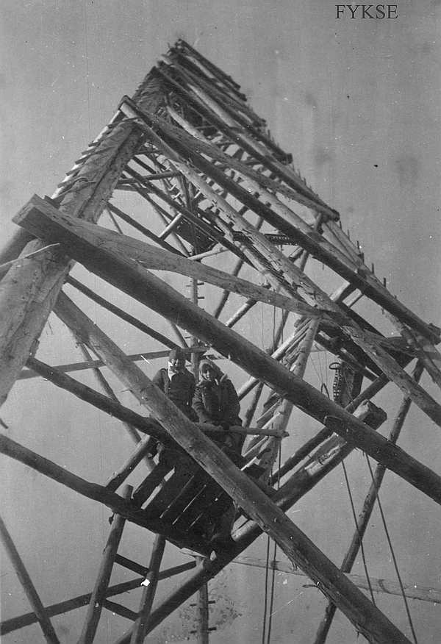
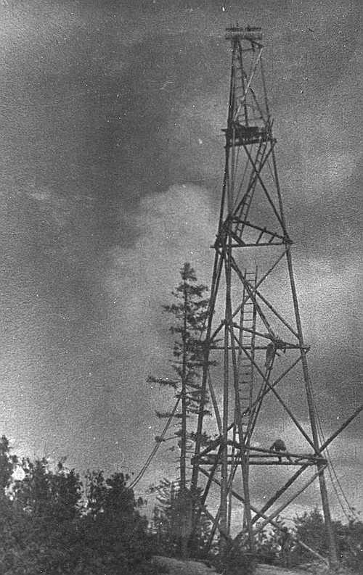
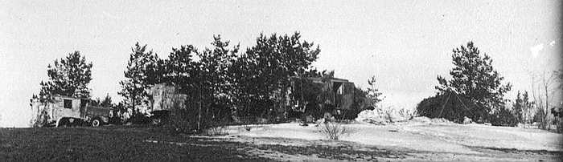

Torn.Fu.d2

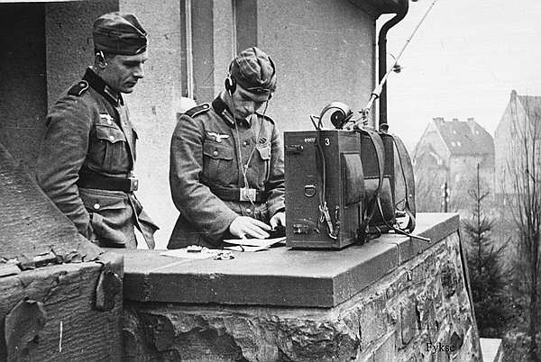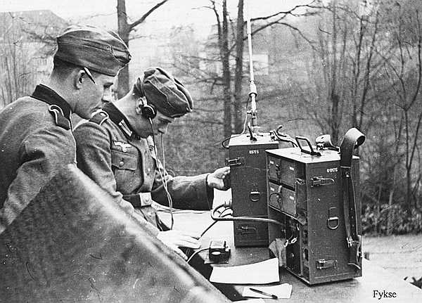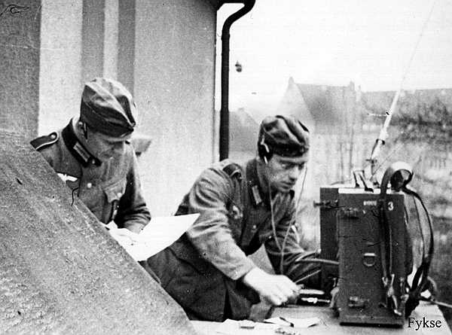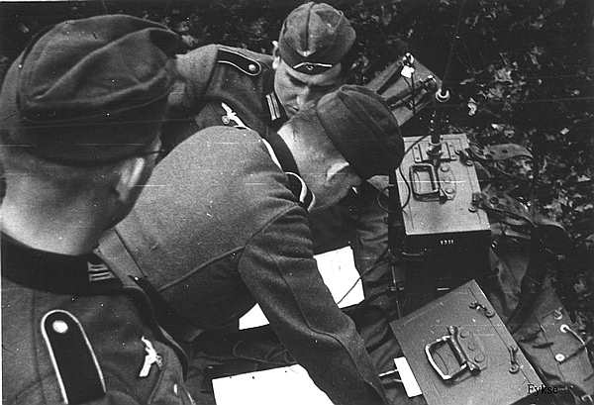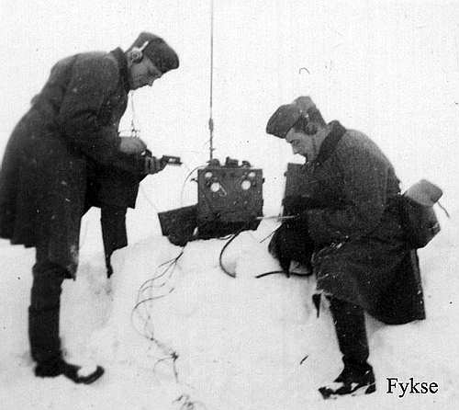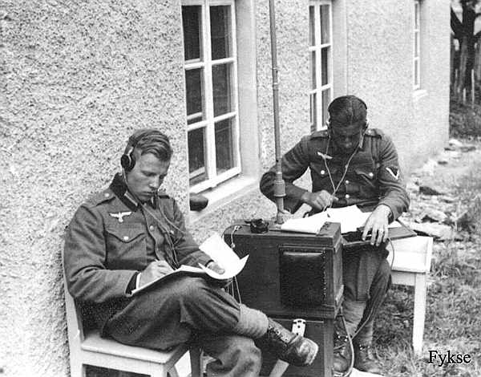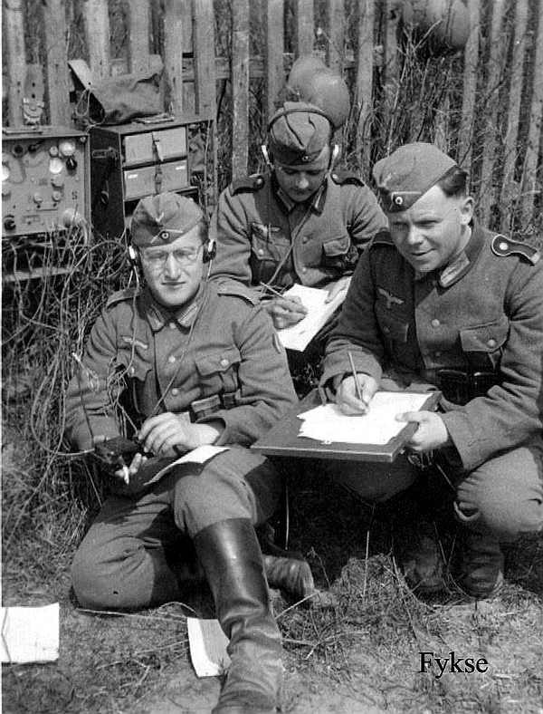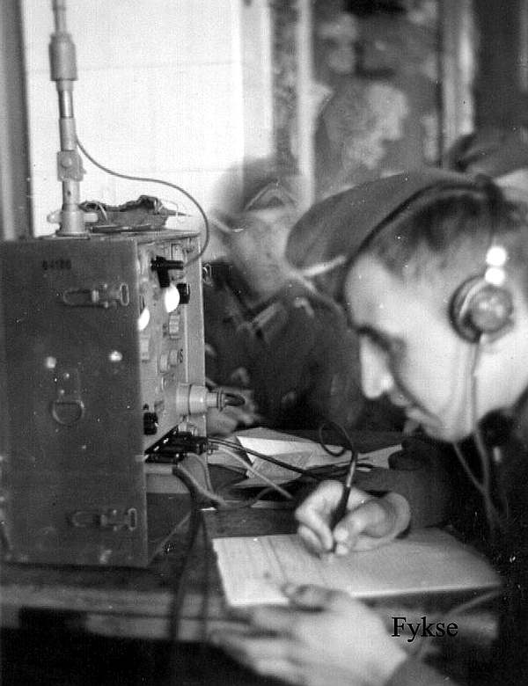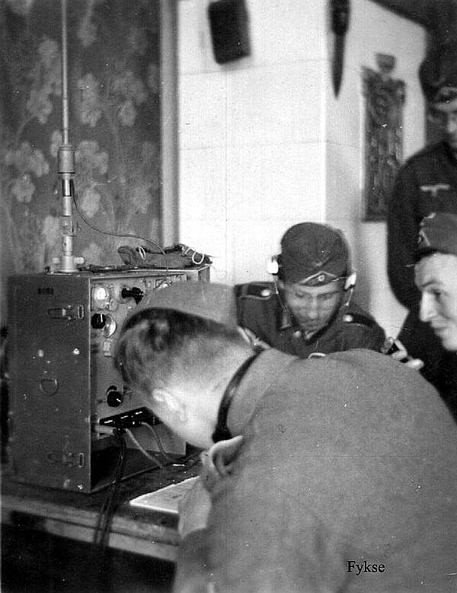
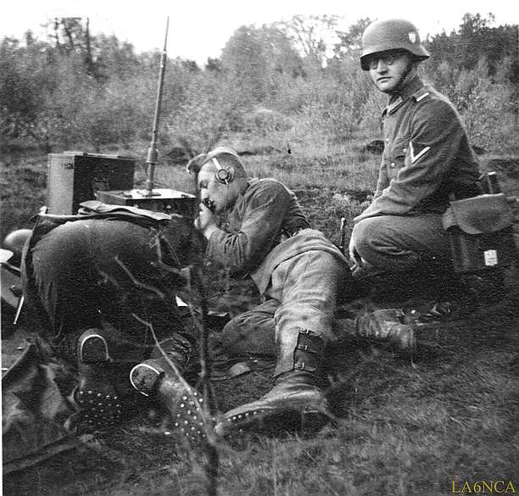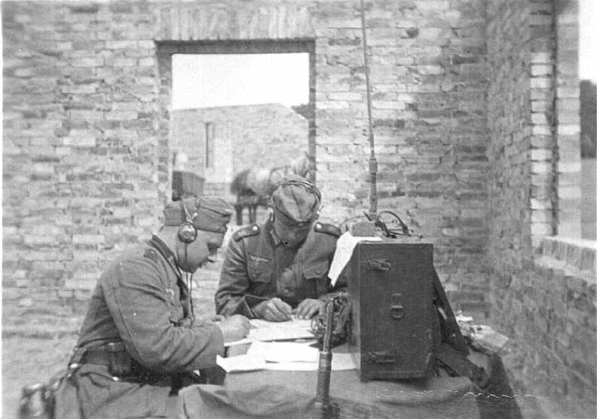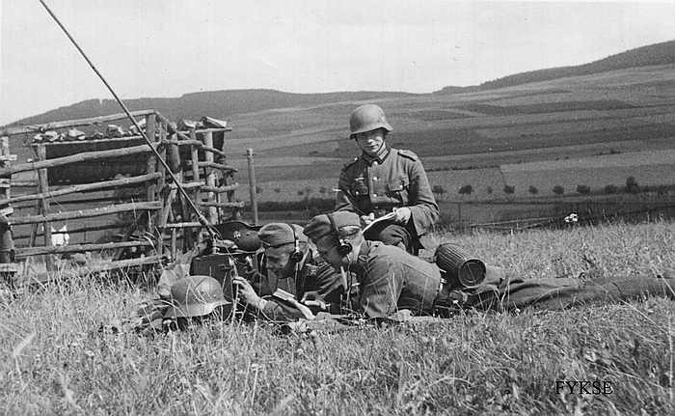
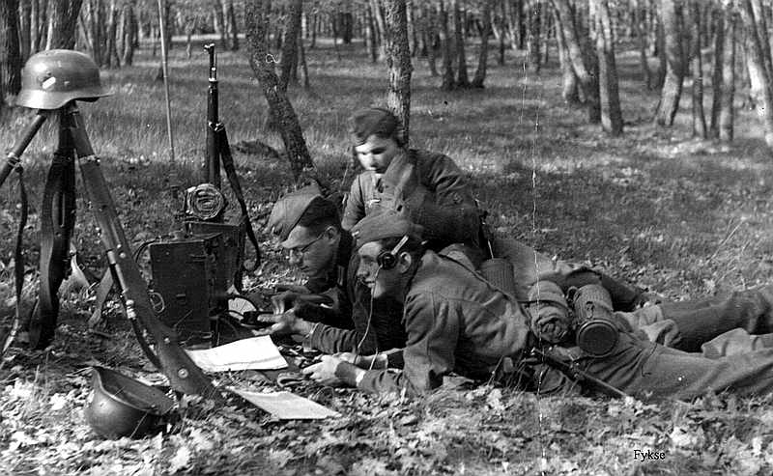

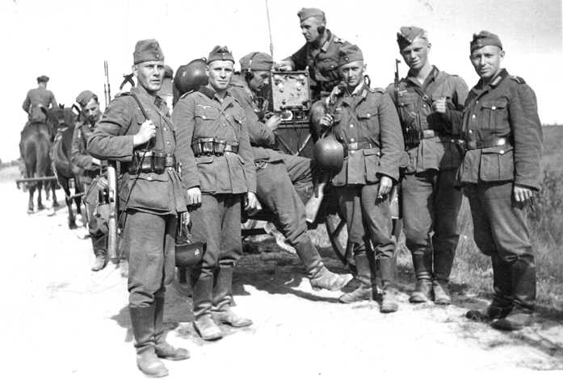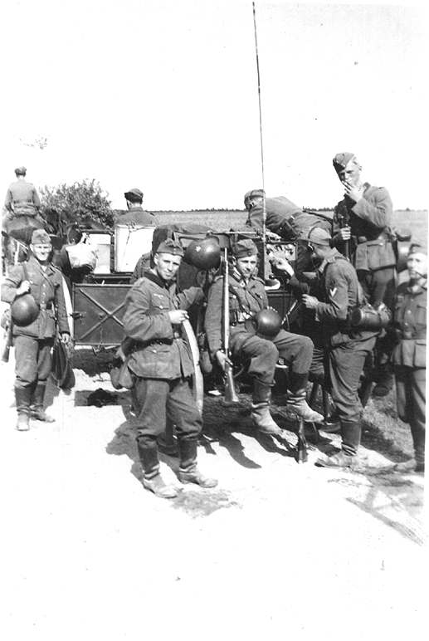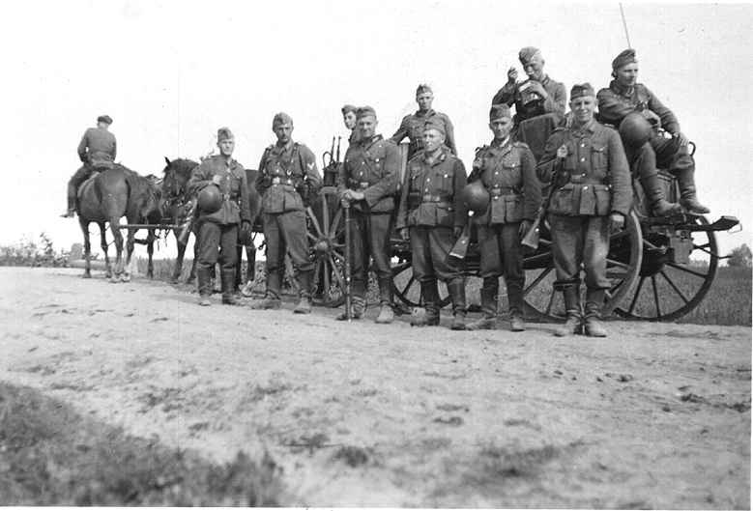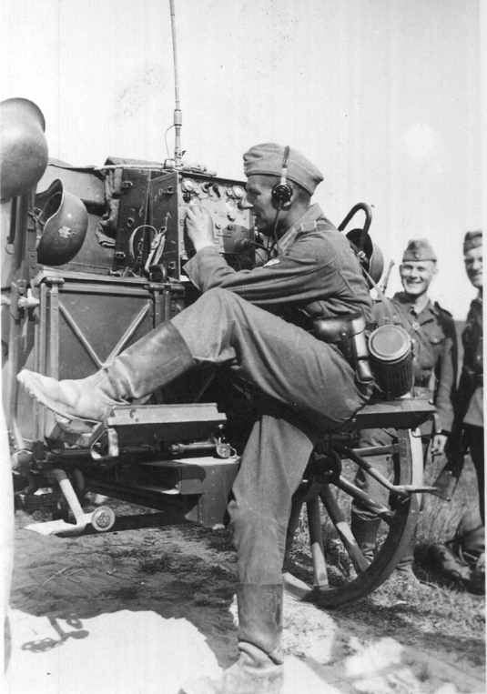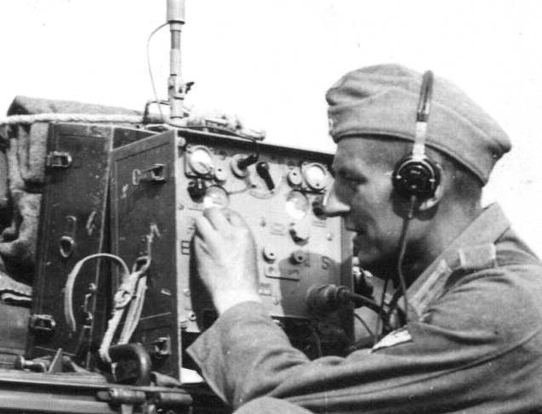

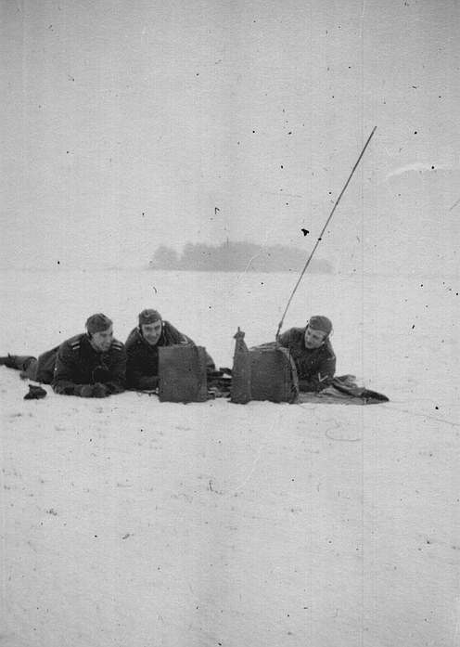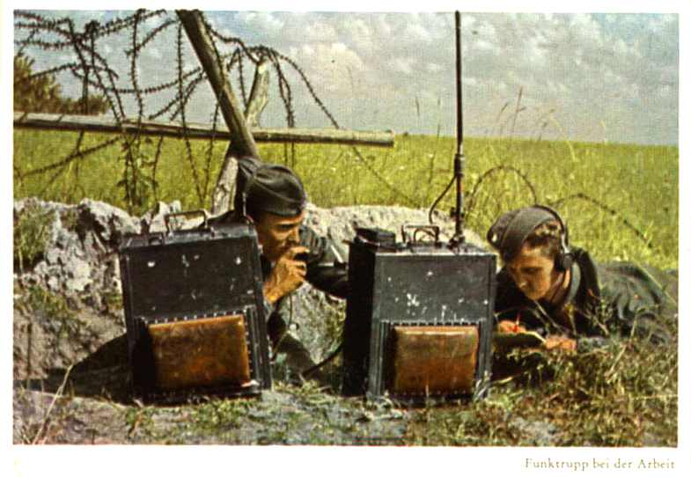

ALBUM PHOTOS
These are photos from an album taken by a radio operator in the German Army.

Radio education in Lübeck October 1940
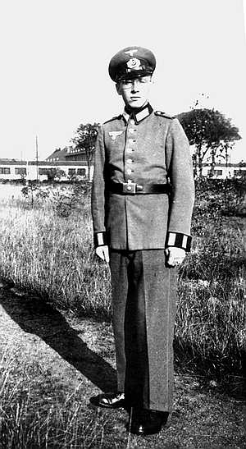
Here is the photograph who has taken the photos in this album.
His name is unknown.
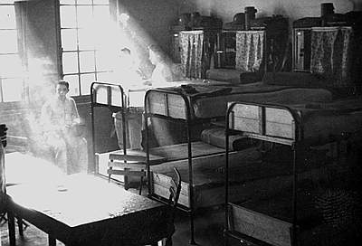
Here is his room.
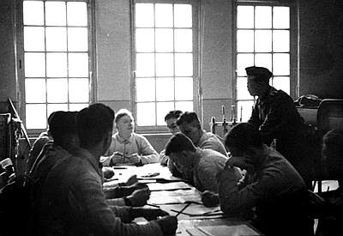
Working with theoretical subjects.
The teacher is standing to the right.
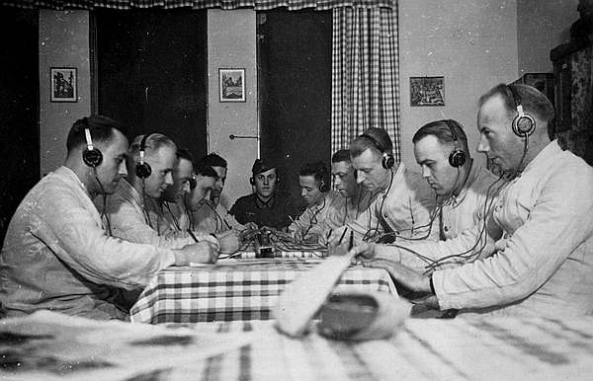
From the CW exercise room.
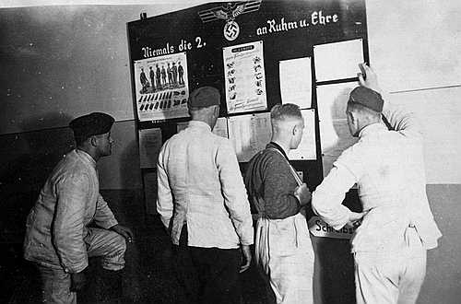
From the notice board in the corridor.
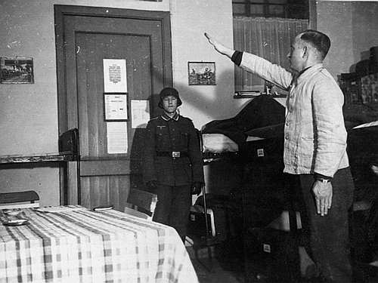
Room inspection.
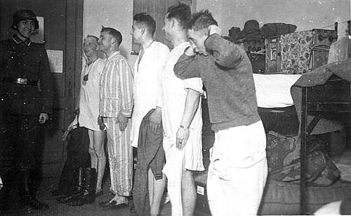
Room inspection.

Spa - Belgien 1940 / 41
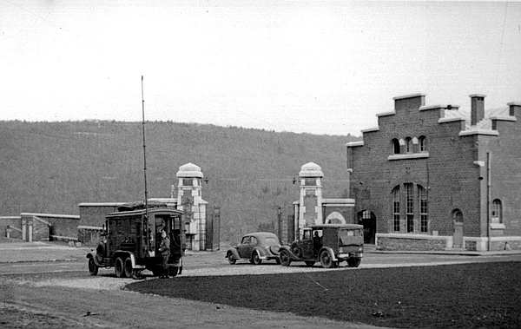
Education is over, and the company is transferred to Spa in Belgium.
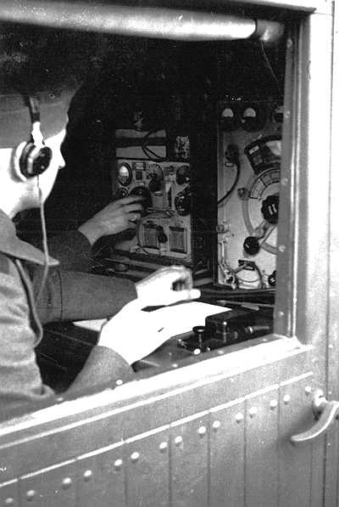
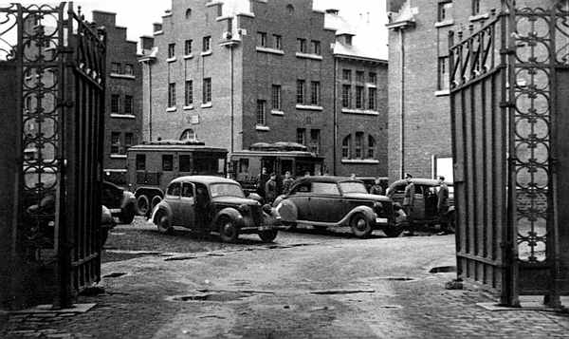
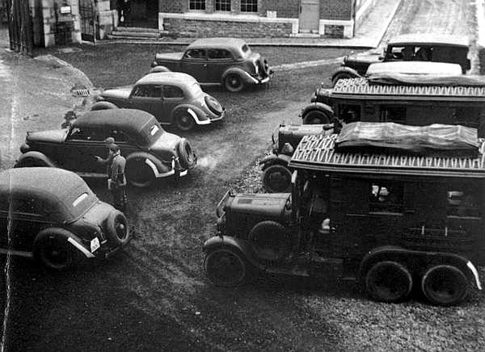
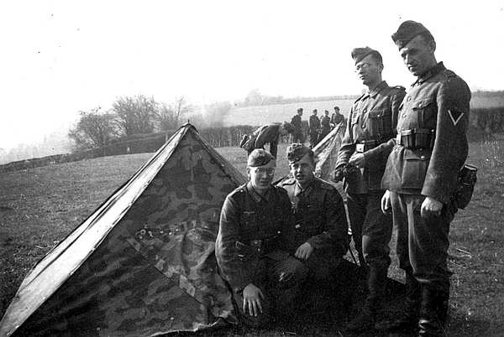
Button tent in use.
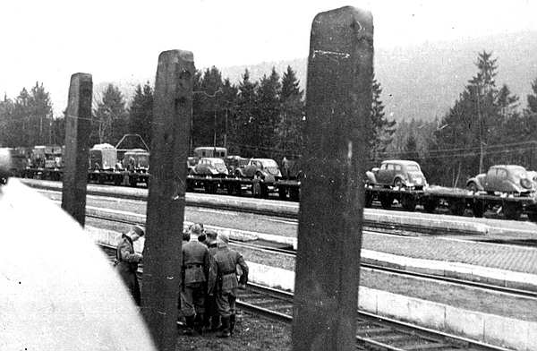
The company is leaving Spa.

Elbing mai 1941
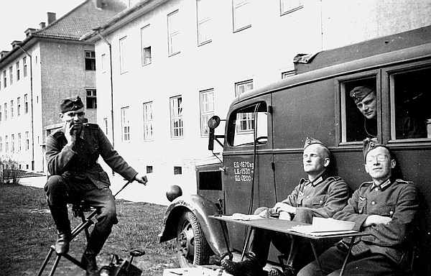
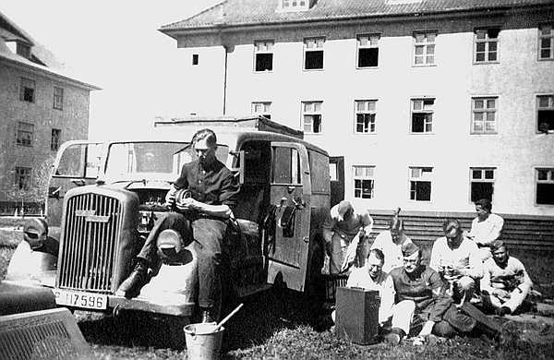

Russland juli 1941
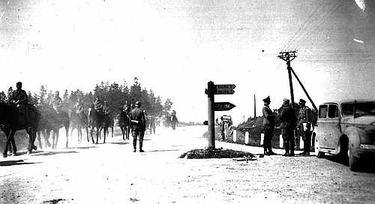
The company has here arrived in Russia.
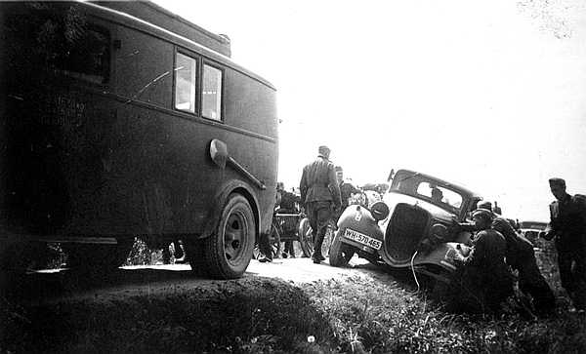
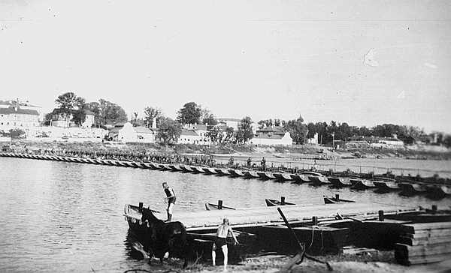
Big boat bridge somewhere in Russland.
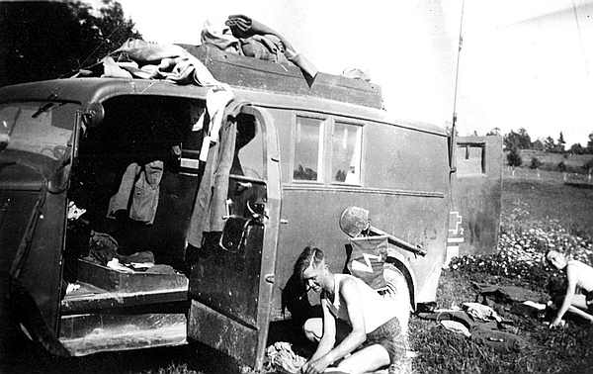
Opel Blitz radio vehicle.
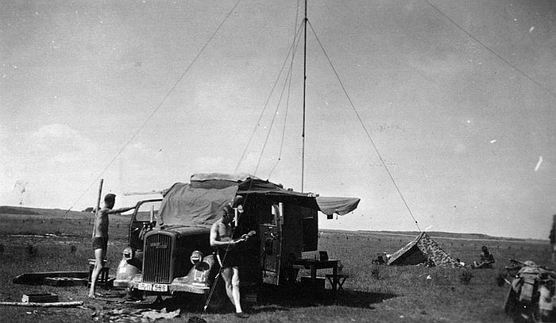
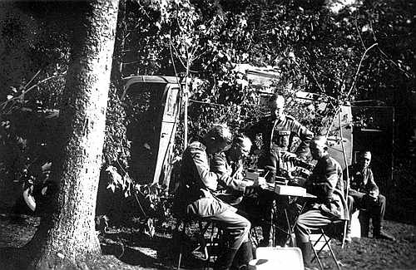
Camouflage.
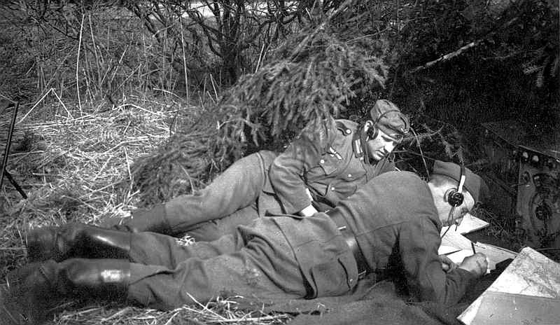
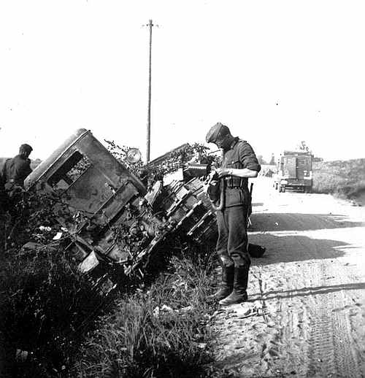
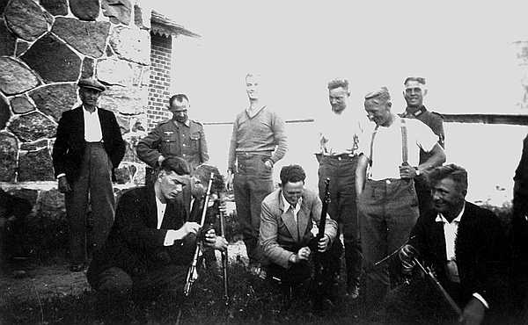
From Eastland. Volunteers get weapons from the German army.
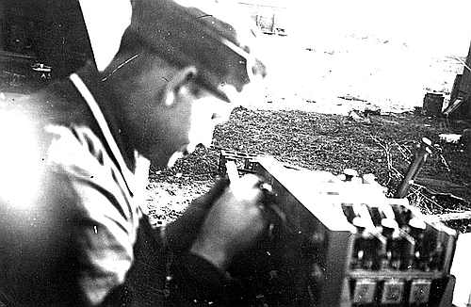
Field repair of Torn.E.b receiver.
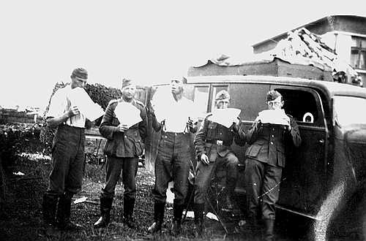
Food break.

Lazarett - Hospital, Elbing oktober 1941
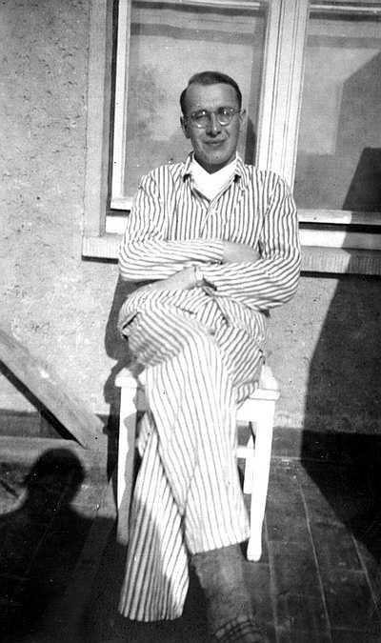
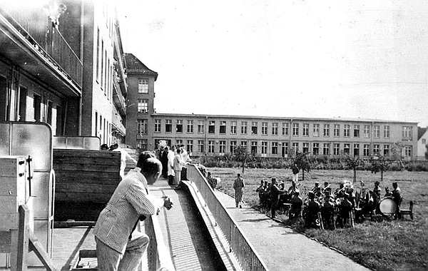
Music for the patients.
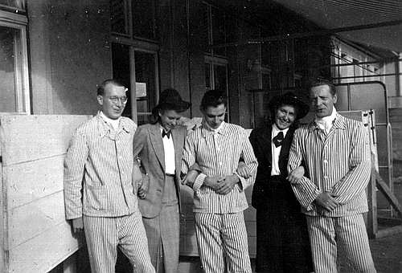
Visitors.
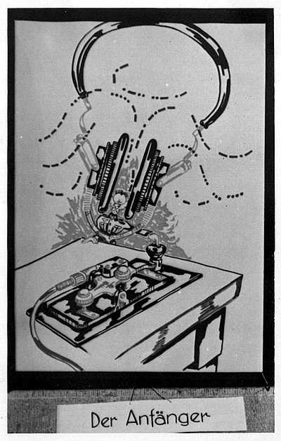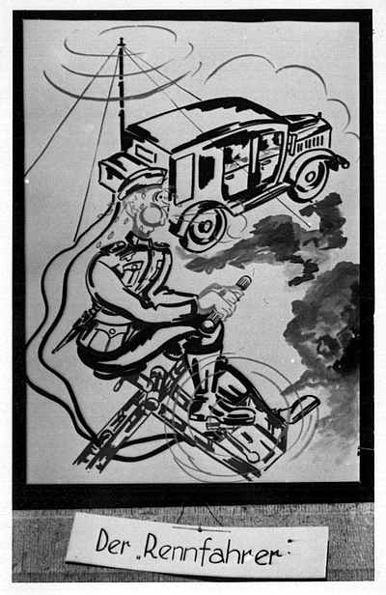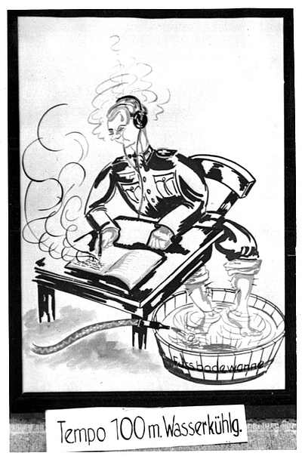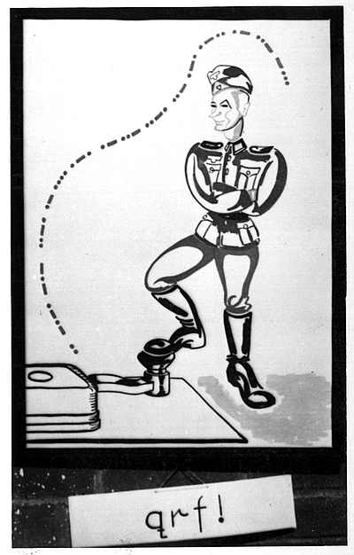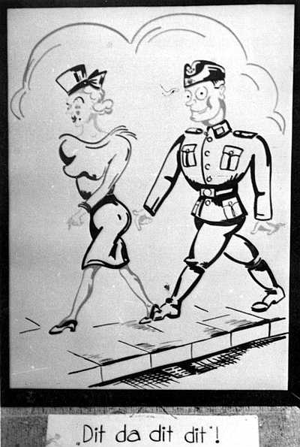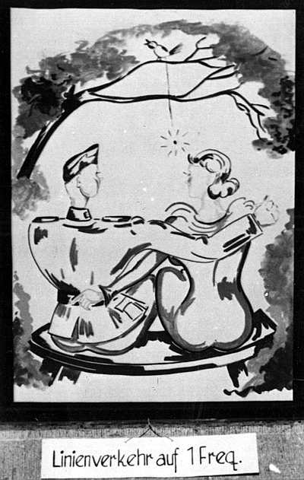

GERMAN WWII PHOTOS
UTSTYR
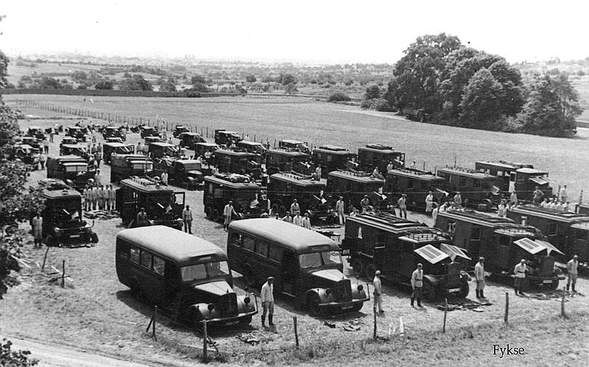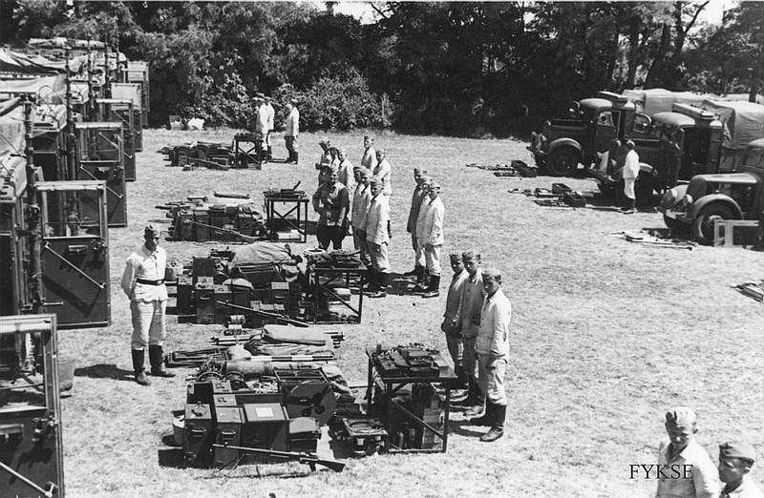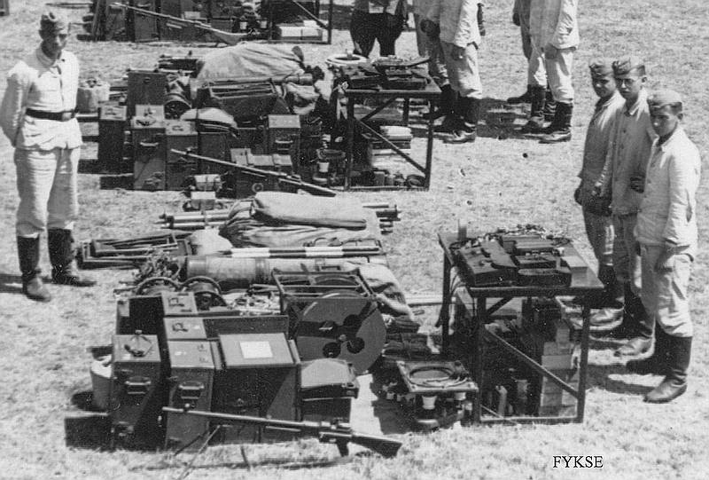

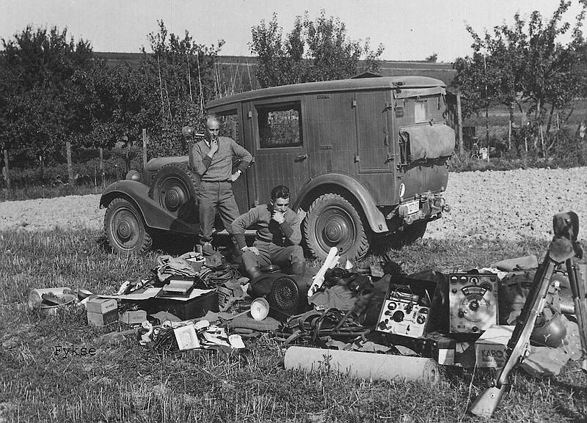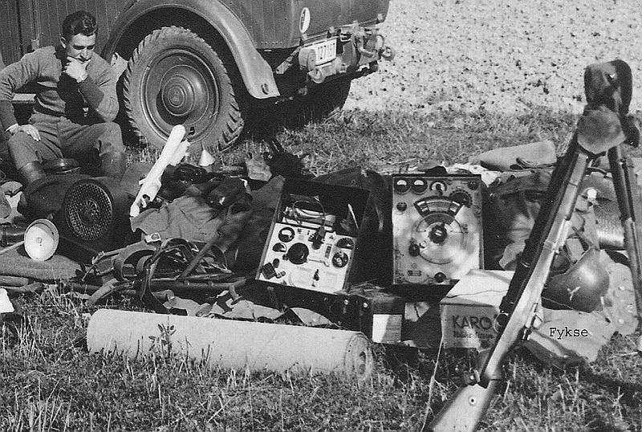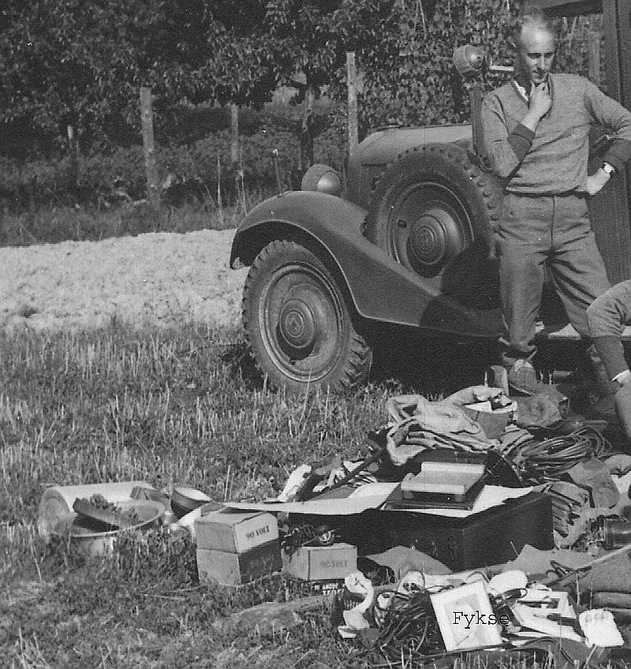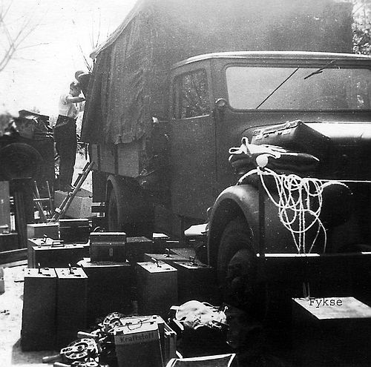

PHOTOS No_2
GERMAN SIGNAL TROOP IN RUSSIA

PICTURES FROM A FIELD TELEPHONE SWITCH INSTALLATION IN RUSSIA.
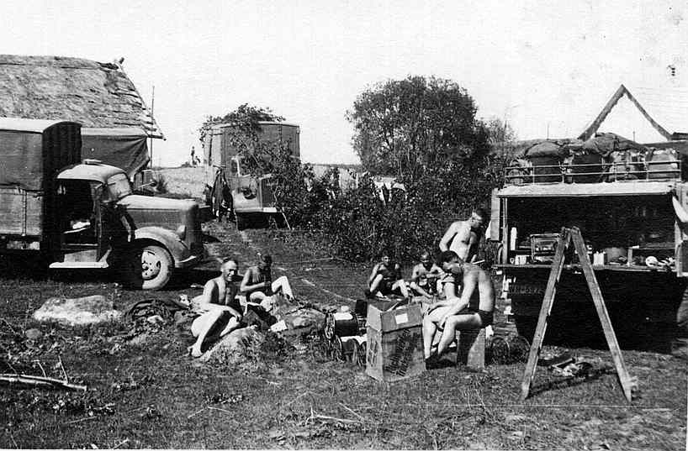
Here are some of the troop's vehicles and signal equipments.
The soldiers are working with the signal equipment.

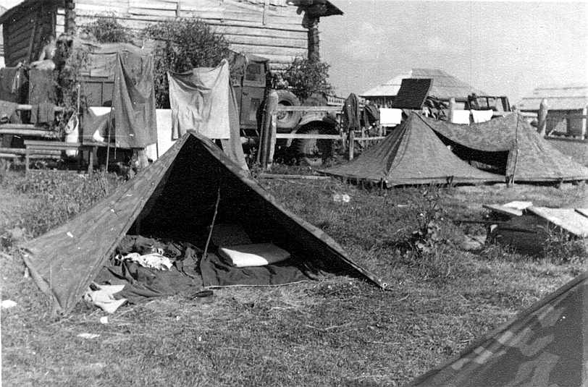
The tents were the signal soldiers lived in the field.

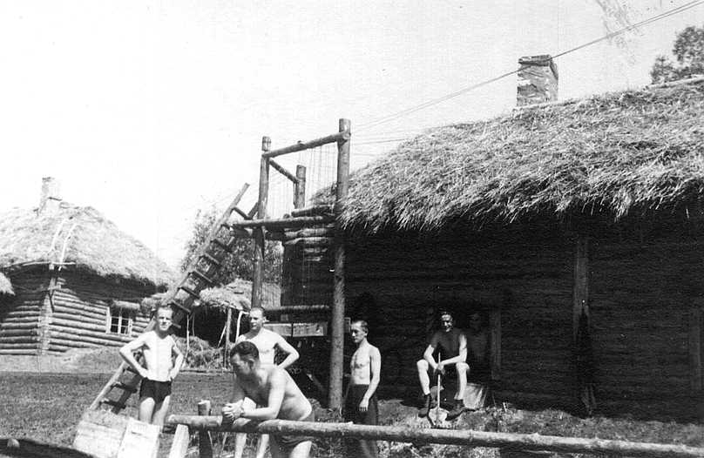
Here is the telephone switch house. All telephone lines is tied up in the wooden poles
before they are terminated in the switch inside the house. Field cables are used. The
lines comes from different German army sections.
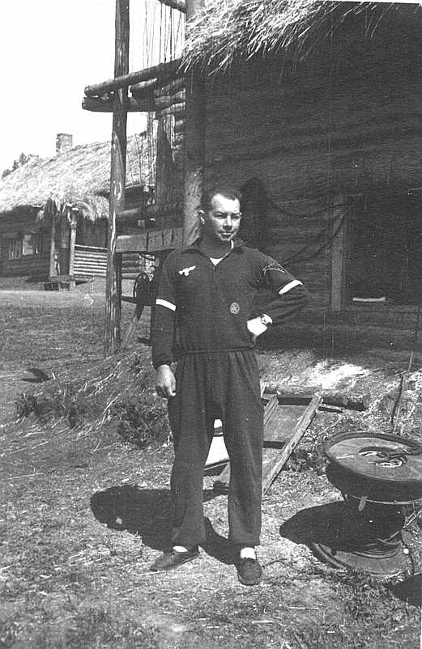

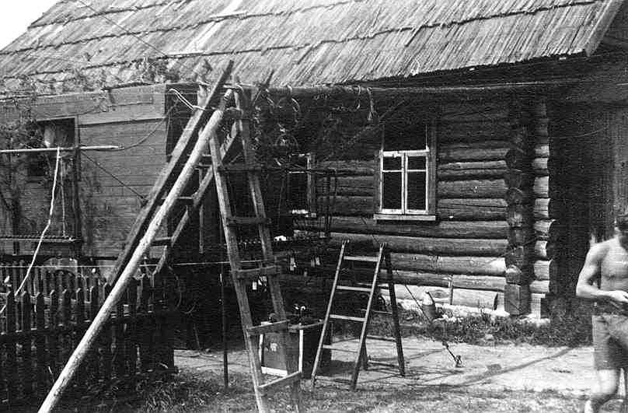
Here is another telephone switch house. Look at all the field cables outside the house.

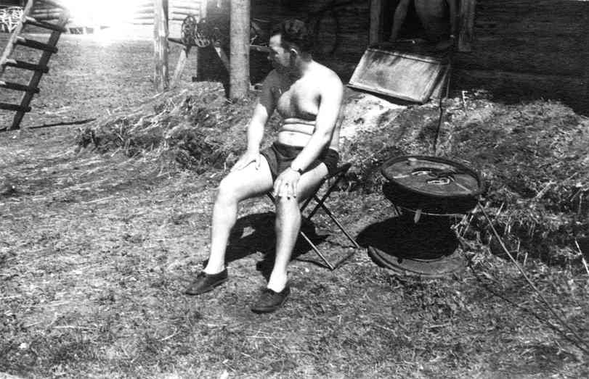
Her is multi-cable used. This is a 10 par cable connected directly in to the switch with a multi-plug.

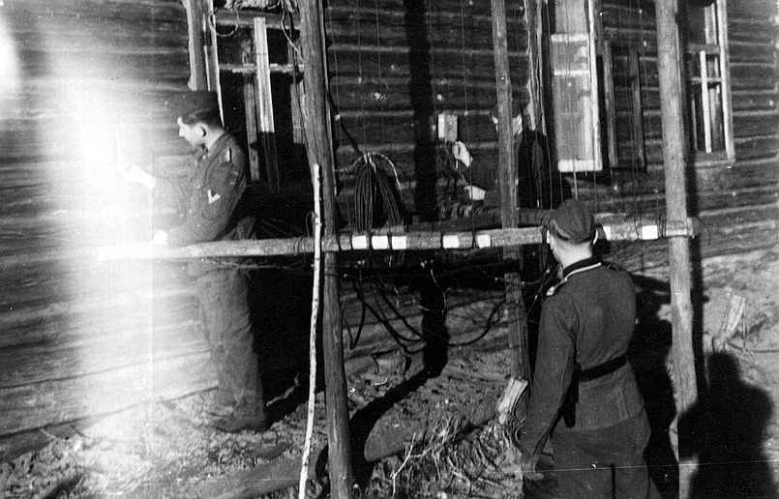
Her is more multi-cables outside a switch house.
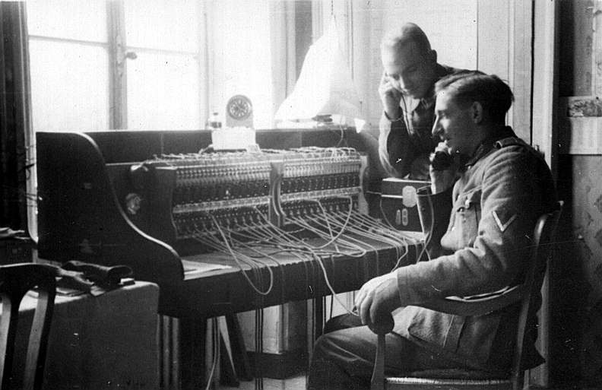
Inside the house. Here is a 24-line switch.
Hmmm… this was interesting!!!
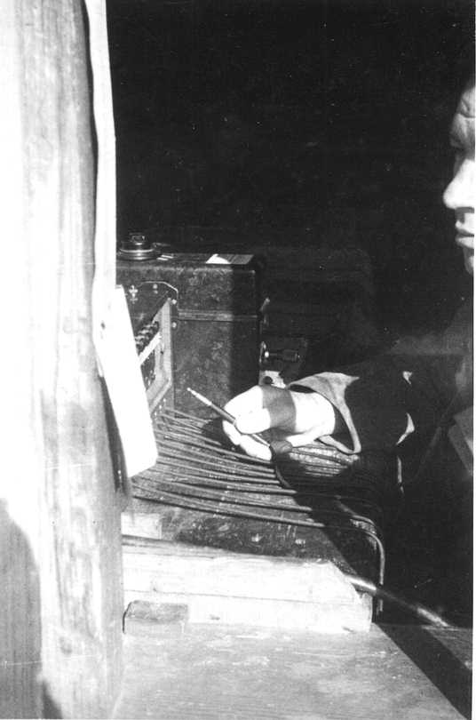
This is from the other house. This is a 10-line switch. The FF33 seen in the back (Feldfernsprecher 33) is also in use.

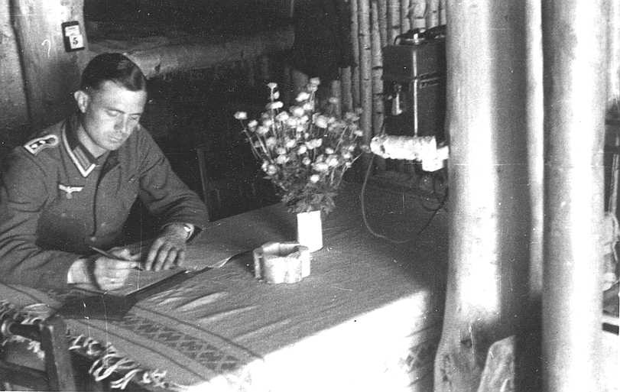
Her is one of the telephones terminated to the line connected to the switch.
Look at the flowers.
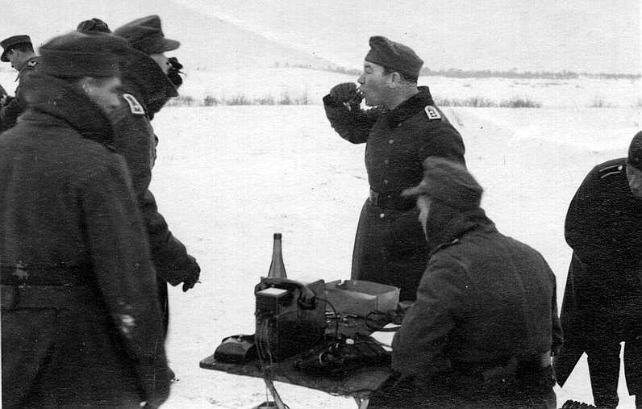
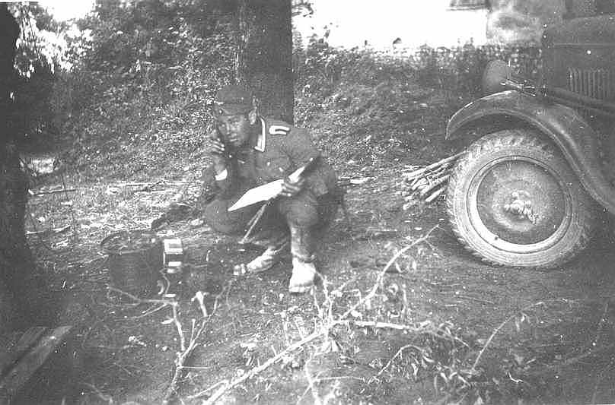
The enemy is not far away. The house is burning in the background.

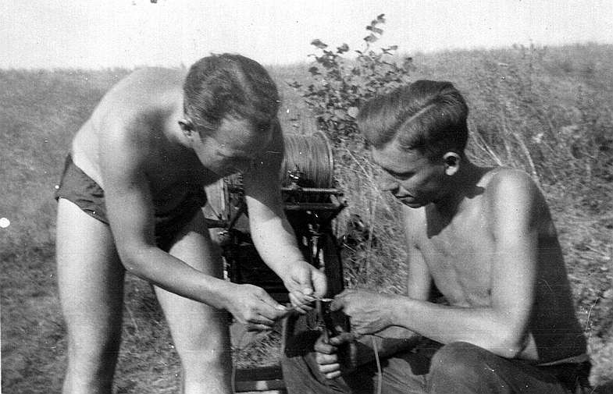
Skjøting av feltkabel i felt.

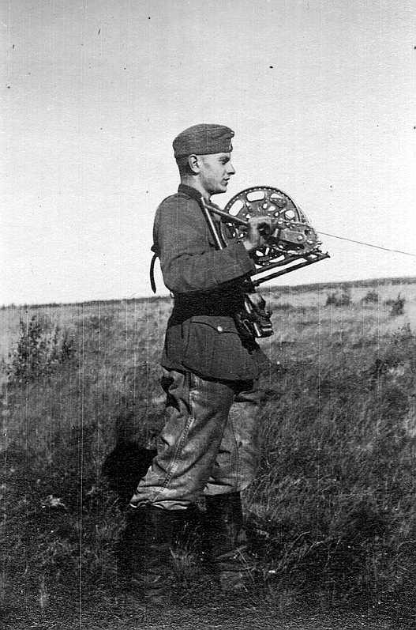
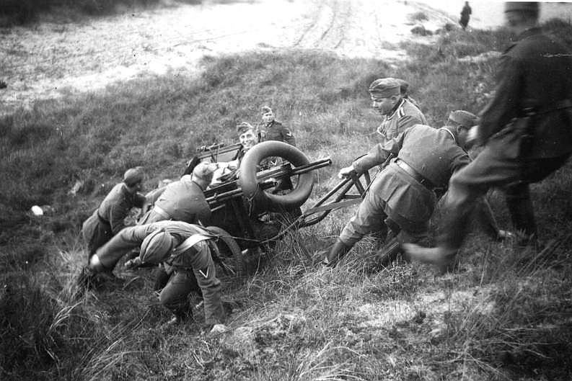
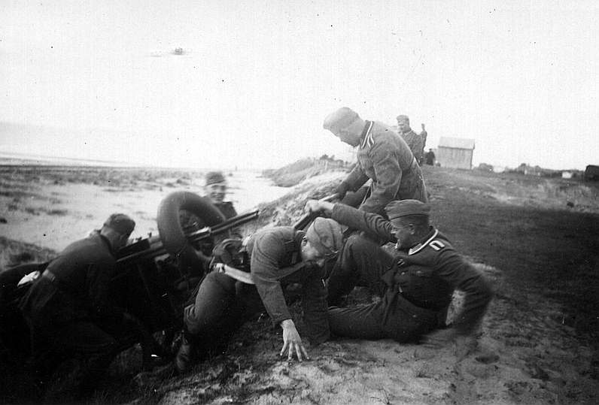
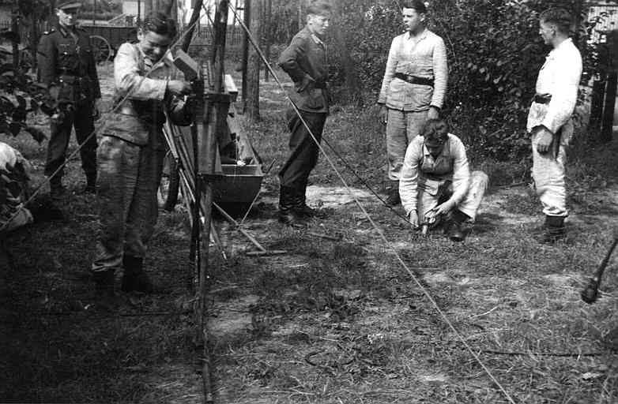
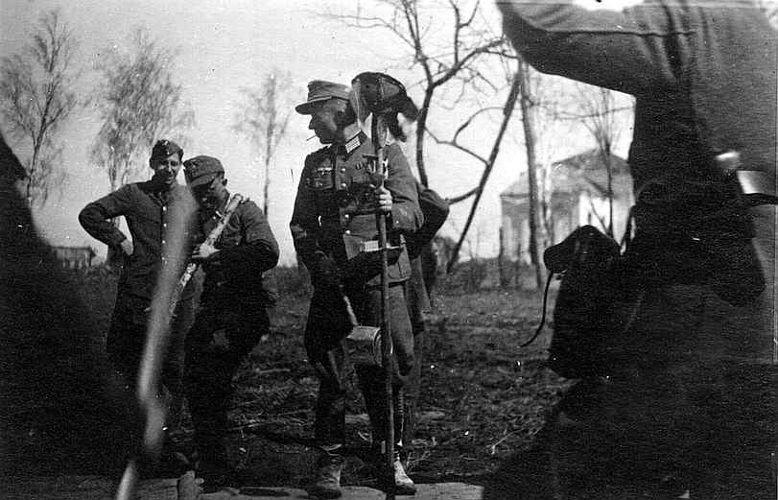

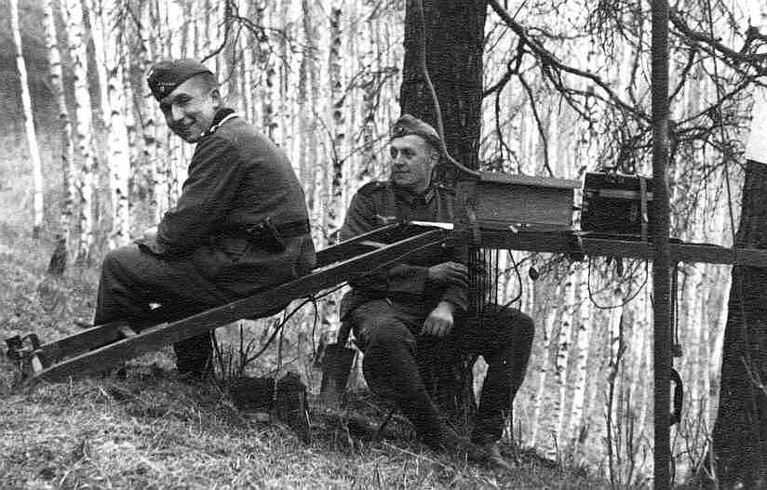
Here is a 10 lines switch mounted outside in the wood. An 10 lines cable is connected to the
switch. An FF33 telephone is used together with the switch.
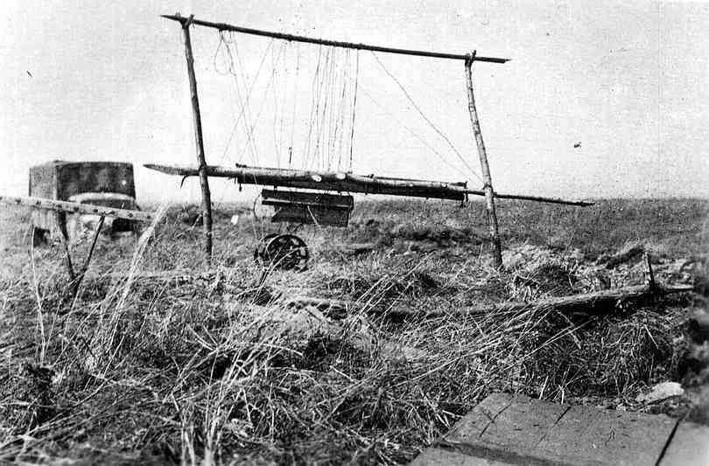

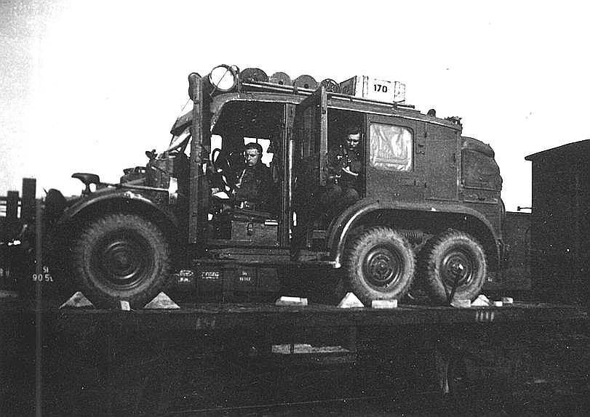
A radio vehicle at train.
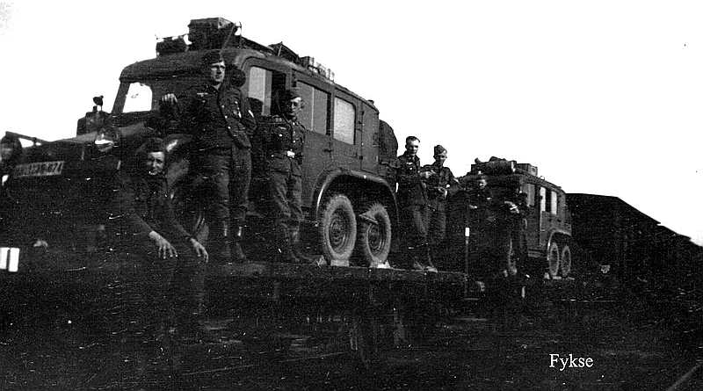
Radio vehicles at train.
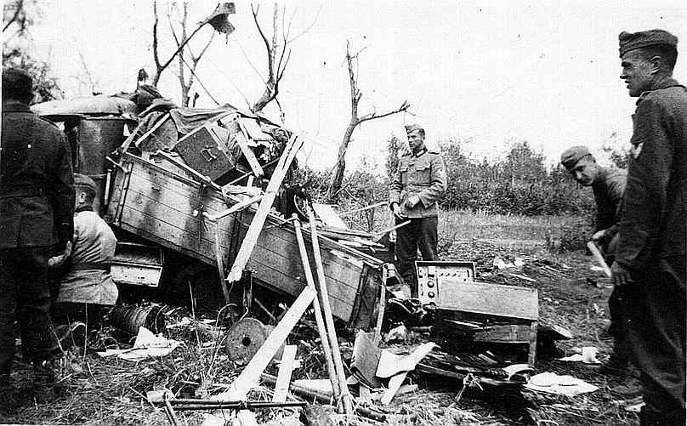
A direct hit. The enemy has hit the vehicle with artillery. Radios and telephone equipment is spread out on the ground.

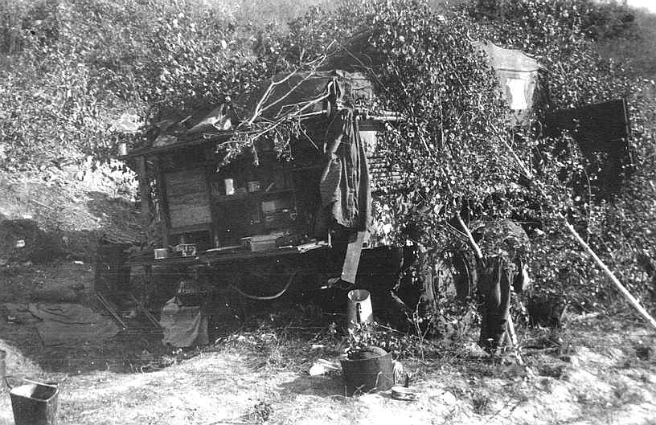
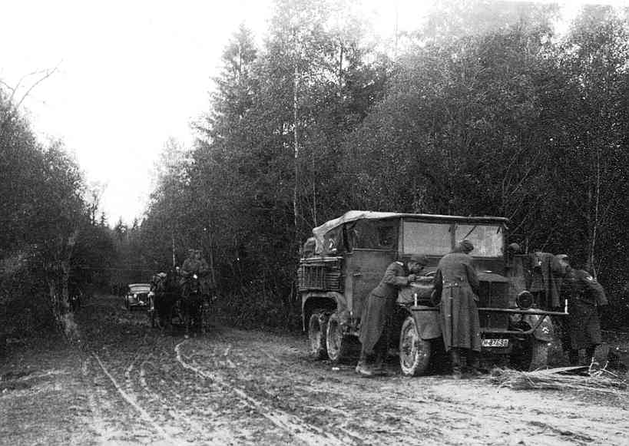
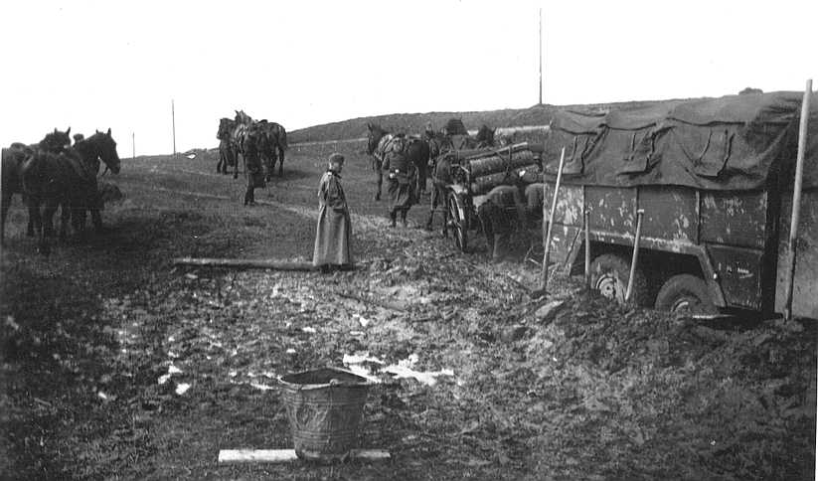
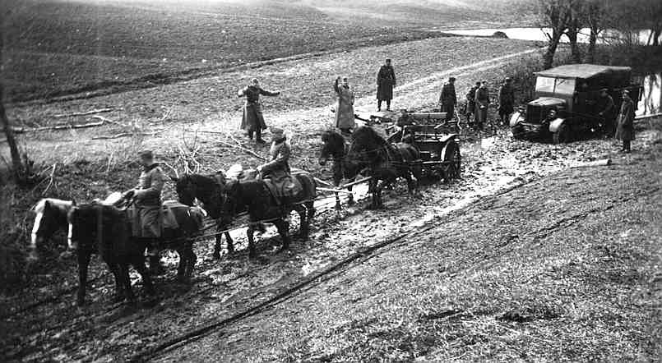
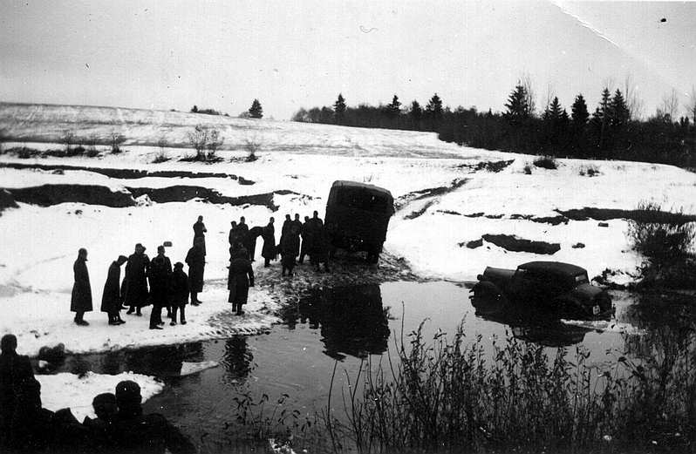
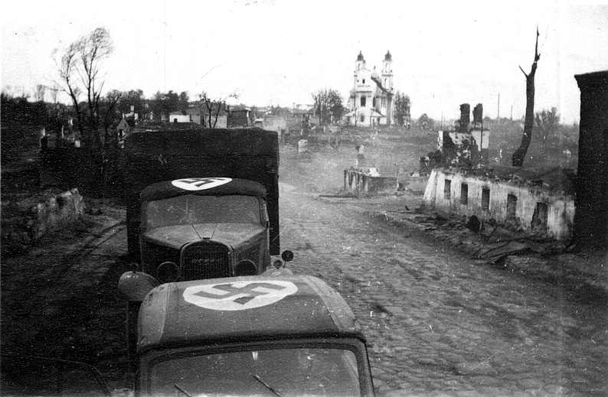
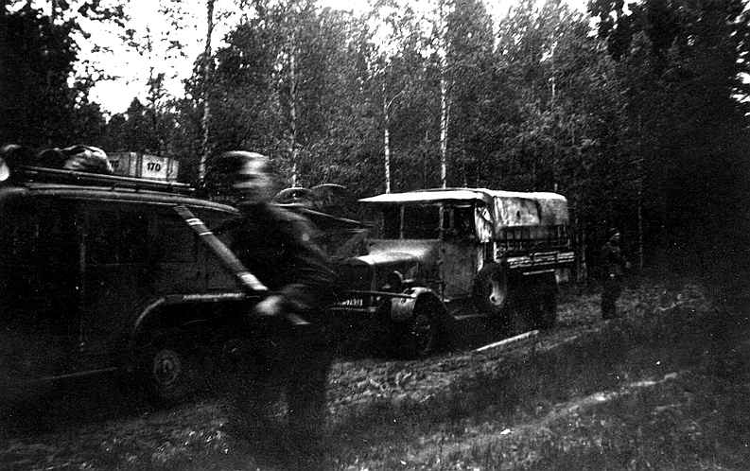
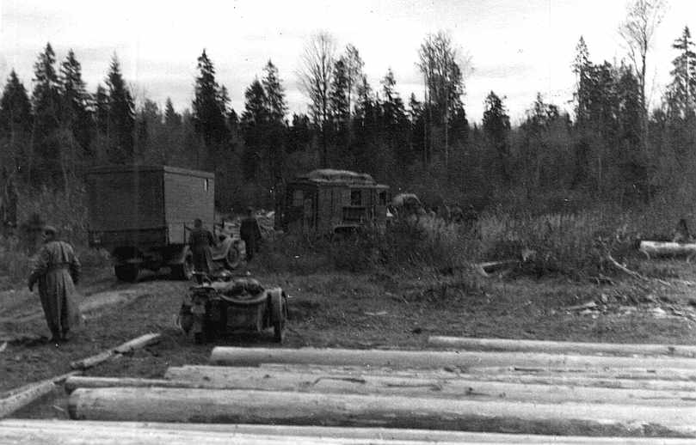

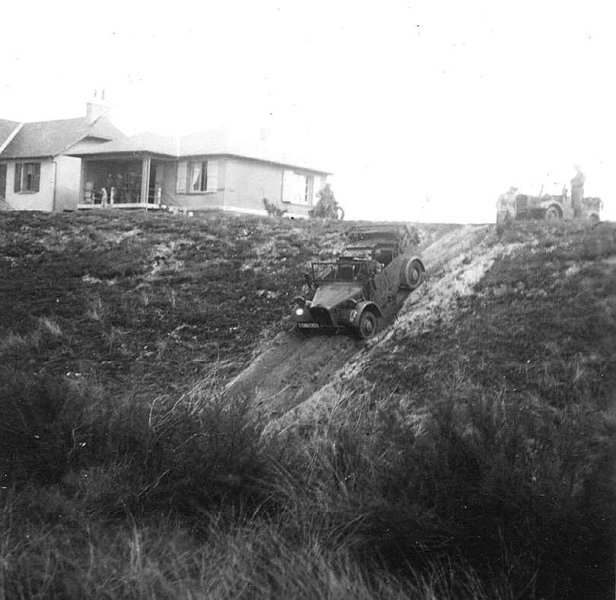

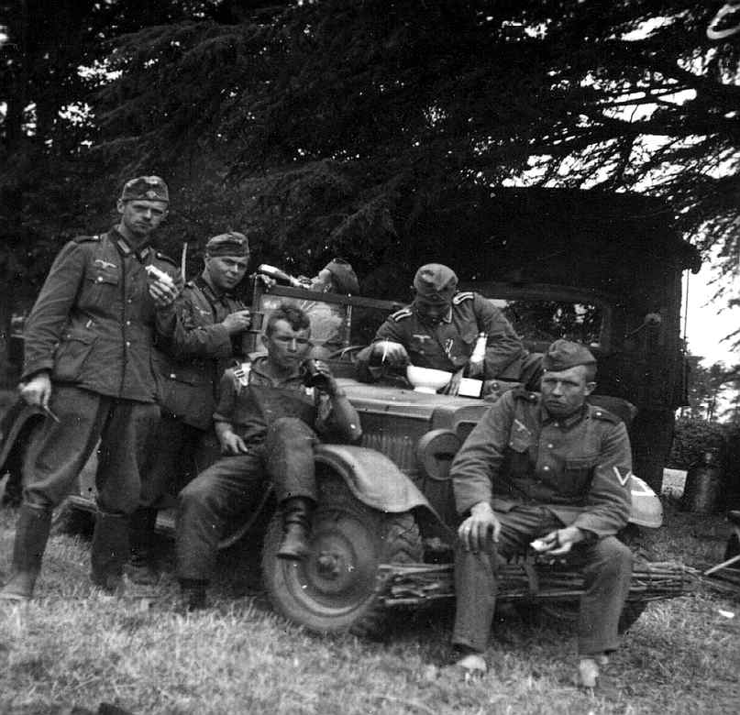
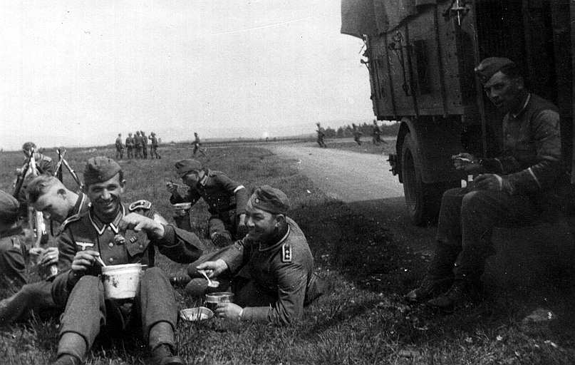
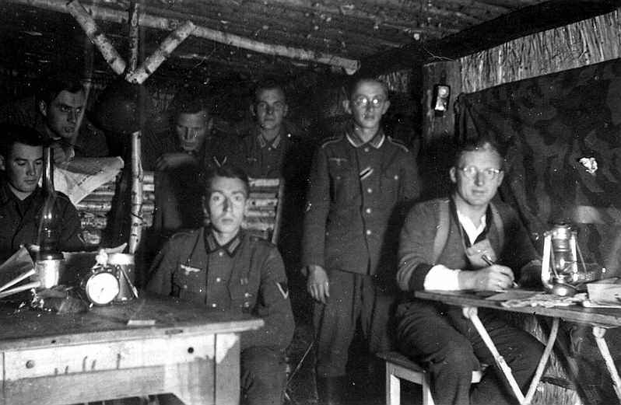

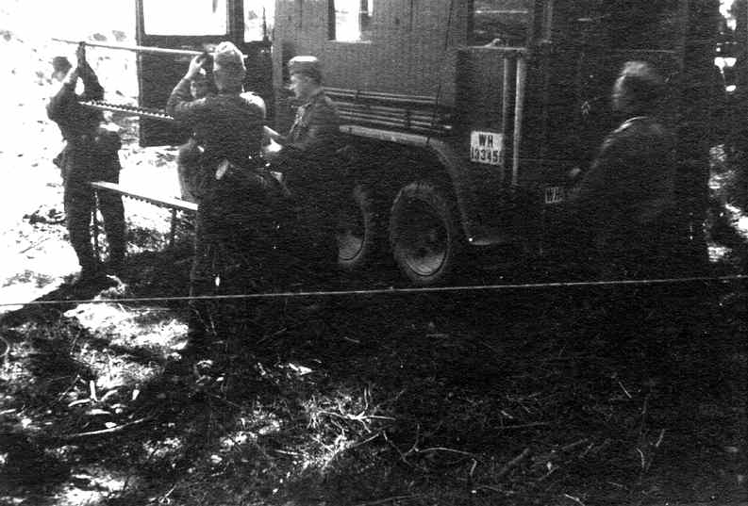

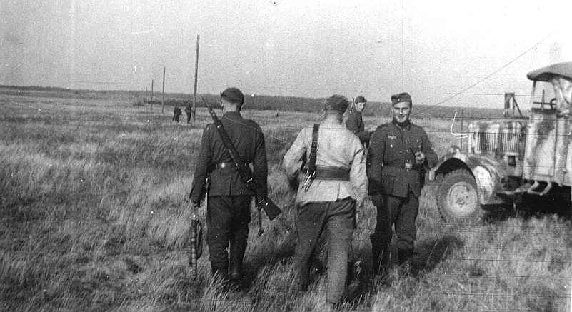

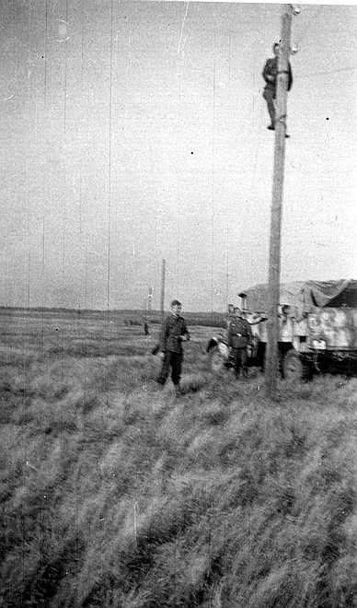

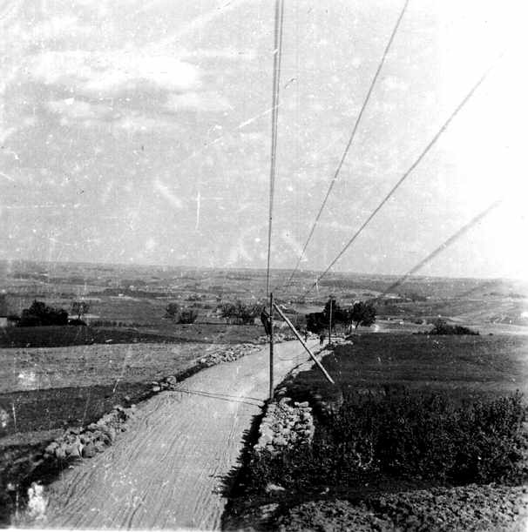

Radio direction finding
.

Train.


